- Materia: Lengua E. “Inglés”
- Profesora: Rodriguez Brea Nahir
- Curso: 1 B
- Bibliografía actual: Unidad 4 Metro Starter (Second Edition)
- Bibliografía a utilizar en el año: Metro Starter (Second Edition)
Material adicional proporcionado por la docente de fuentes como: https://www.liveworksheets.com/es - https://busyteacher.org/https://www.superteacherworksheets.com/index.html- https://www.planitteachers.ai/ Entre otras.
Trabajo Práctico N° 49
PRESENT SIMPLE (I-YOU-WE-THEY)
Activities: Complete exercises n° 4 and 5
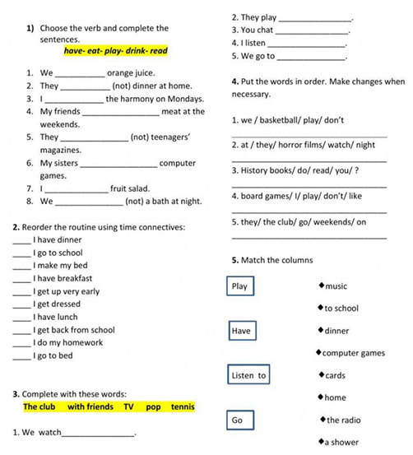
Reading comprehension:
Hi! We are students at Green School. We start classes at 8 o'clock every morning.
We study English, Maths, Science and History. We like English because we play games and listen to music in class.
At break time, we eat sandwiches and drink water. We don't drink soda at school.
After school, we go home. Some students play football, and others listen to music or read books.
We usually do our homework in the afternoon. At night, we watch TV or play games with our families.

A. TRUE OR FALSE
- They start school at 8 o'clock. ______
- They study English. ______
- They don't like English. ______
- They drink soda at school. ______
- They play football after school. ______
- They do their homework in the afternoon. ______

