Materia: LENGUA EXTRANJERA “INGLÉS”
Docente: Ortiz, Irma A.
Curso: 6° A
Bibliografía: Metro 3 – Oxford

Trabajo Práctico N° 24
Miércoles 09 de septiembre de 2026

Página: 89
Unidad 8: Creativity
Revisión de la tarea: pág. 91, punto 3 y 4
Actividad: pág. 92, punto 2. Elegir uno de los textos para traducir.
Trabajo Práctico evaluativo, sobre los adjetivos de la pág. 90

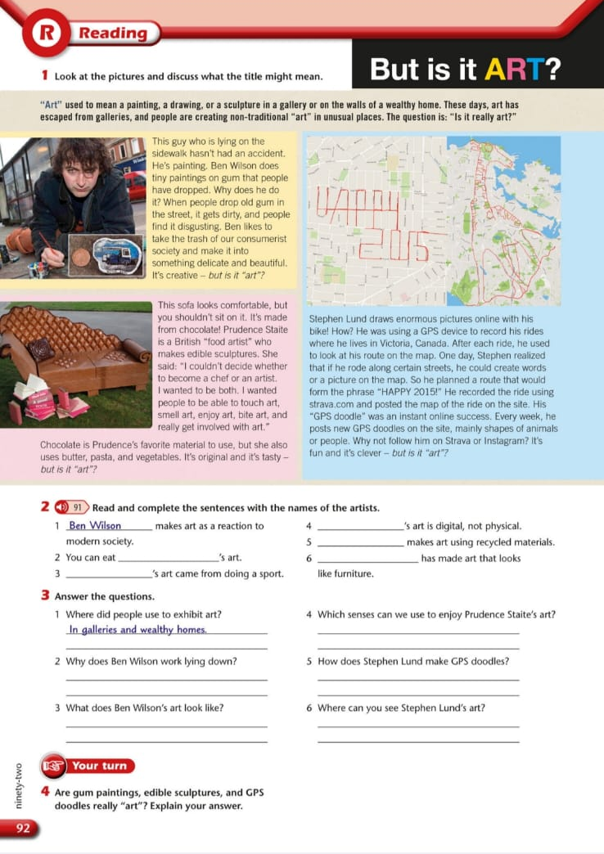

TRABAJO PRACTICO EVALUATIVO
Art Walk Description
Look at this! We are walking down the street in the art district, and everything we see is amazing.
First, we are looking at an ______________ painting on the wall of an old house. Next to it, there is an ______________ sculpture made by a local artist. It looks very ______________ because it has no face!
All the materials used here are ______________ plastic and paper found in the neighborhood. Look down—there is a ______________ drawing of a cat hidden on the sidewalk. Across the street, we see an ______________ brick wall from the very first buildings of our city.
The artist who made this is very ______________ because she used the shadows of the sun to create shapes. Be careful with that paper mask on the table; it is very ______________ and can break easily. Finally, look up at that ______________ mural on the tall building. It covers the whole wall!

