Materia: LENGUA EXTRANJERA “INGLÉS”
Docente: Ortiz, Irma A.
Curso: 4° A
Bibliografía: Metro 2 – Oxford

Trabajo Práctico N° 24
Jueves 17 de septiembre de 2026

Unidad 3: Good job!
Revisión de la Tarea: Pág. 40, puntos 1,2 y 3
Grammar: Not as…. as (pág. 41)
Grammar: Too or enough (pág. 41)
Tarea: Pág. 42, puntos 1. Pág. 42 y 43
Trabajo Práctico Evaluativo
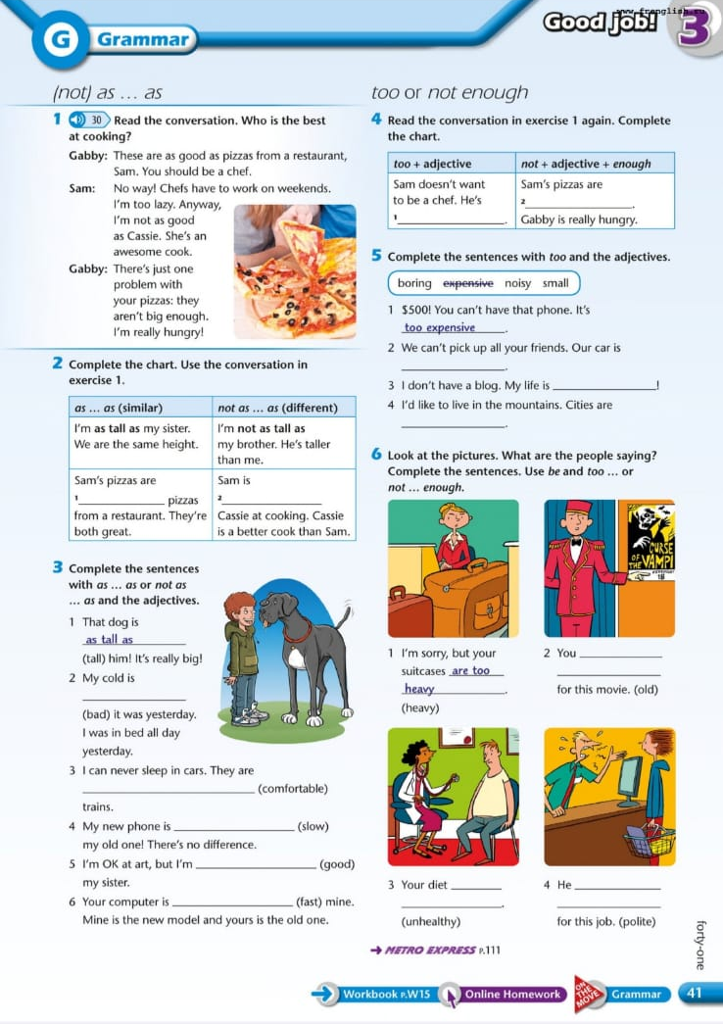
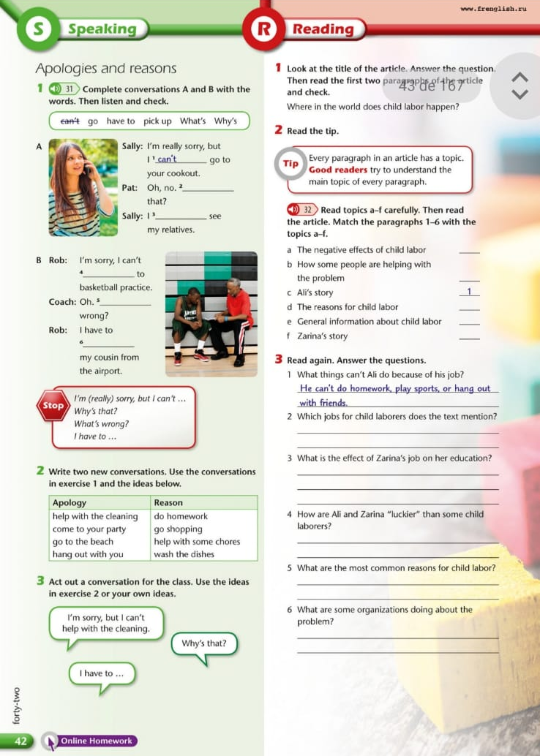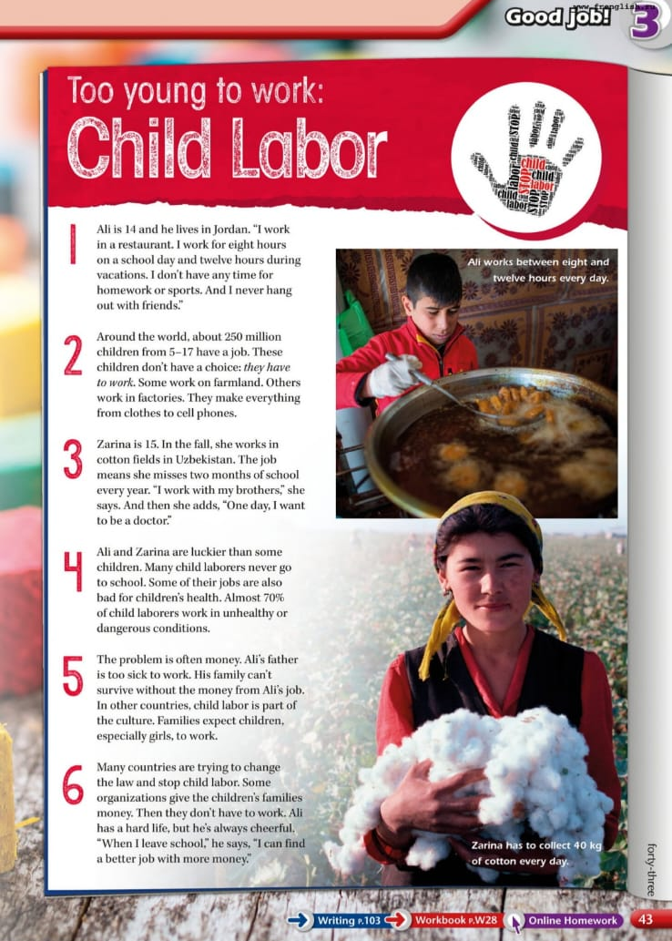

Trabajo Practico Evaluativo –TP 24 Name:_______________________________
1. Complete the sentences with the correct job from the box.
architect • chef • dentist • fashion designer • lawyer • nurse • police officer • software developer
- ____________________ designs clothes and creates new fashion trends.
- ____________________ checks people's teeth and treats oral problems.
- ____________________ helps patients in a hospital alongside doctors.
- ____________________ designs houses, buildings, and structures.
- ____________________ prepares delicious food in a restaurant kitchen.
- ____________________ creates computer programs and apps.
- ____________________ represents people in court and knows about laws.
- ____________________ protects citizens and maintains order in the city.

2. Choose the correct personality adjective.
- Lucas is very ( cheerful / miserable ). He always smiles and makes people happy.
- Maria gets ( anxious / confident ) before big exams; her heart beats very fast.
- The cashier was very ( polite / rude ); he shouted at the customer for no reason.
- Martin is ( lazy / hard working ). He works 10 hours a day and loves his job.
- Sofia is ( shy / easy going ). She doesn't like speaking in front of big groups.
- Marcos is really ( helpful / unhelpful ). When you have a problem, he always offers a hand.

3. Complete with have to, has to, don't have to, or doesn't have to.
- A doctor ____________________ study for many years before practicing medicine. (obligation)
- A salesperson ____________________ be polite to customers all the time. (obligation)
- Journalists __________________wear a strict uniform, they can wear casual clothes.(no obligation)
- A receptionist ____________________ be unhelpful; they must assist visitors. (negative rule)
- A chef ____________________ clean the entire restaurant floor; assistants do that. (no obligation)
- Police officers ___________________carry out their duties carefully to protect people. (obligation)

