- Materia: Lengua E. “Inglés”
- Profesora: Rodriguez Brea Nahir
- Curso: 2 A
- Bibliografía actual: Unit 2 Metro 1- (Oxford)

- Bibliografía a utilizar en el año: Libro Metro Starter (Oxford) Metro 1 (Oxford)
Material adicional proporcionado por la docente de fuentes como: https://www.liveworksheets.com/es - https://busyteacher.org/https://www.superteacherworksheets.com/index.html- https://www.planitteachers.ai/ Entre otras.
Trabajo Práctico N° 52
POSSESSIVE PRONOUNS
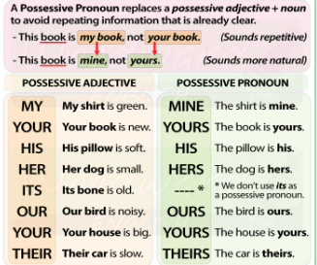
  - Complete the sentences with the correct possessive pronoun: my, your, his, her, its, our, their.
- I have a sister. ___ name is Emma.
- Tom has a new bike. ___ bike is blue.
- We live in a big house. ___ house has three bedrooms.
- You have a beautiful dog. ___ dog is very friendly.
- Sarah has a brother. ___ brother is 12 years old.
- They have two children. ___ children are very happy.
- The cat is eating ___ food.
- I love ___ family.

