- Materia: Lengua E. “Inglés”
- Profesora: Rodriguez Brea Nahir
- Curso: 2 A
- Bibliografía actual: Unit 1 Metro 1- (Oxford)

- Bibliografía a utilizar en el año: Libro Metro Starter (Oxford) Metro 1 (Oxford)
Material adicional proporcionado por la docente de fuentes como: https://www.liveworksheets.com/es - https://busyteacher.org/https://www.superteacherworksheets.com/index.html- https://www.planitteachers.ai/ Entre otras.
Trabajo Práctico N° 48
THIRD TERM
WEATHER AND SEASONS
Weather can change a lot depending on the season. In spring, the weather is usually mild and pleasant. Flowers start to grow, and people enjoy spending more time outdoors. Summer is generally hot and sunny, so many people go to the beach or swimming pools.
In autumn, temperatures become cooler and the days get shorter. It often rains, and the leaves change colour. Winter is the coldest season. In some countries, it snows and people wear warm clothes such as coats, scarves and gloves.
My favourite season is autumn because I love cool weather and rainy afternoons. I also enjoy drinking hot chocolate and watching movies at home.
Comprehension Questions
- What is the weather usually like in spring?
- What do people often do in summer?
- What happens to the leaves in autumn?
- What is the coldest season?
- What clothes do people wear in winter?
- What is the writer's favourite season?
- Why does the writer like autumn?
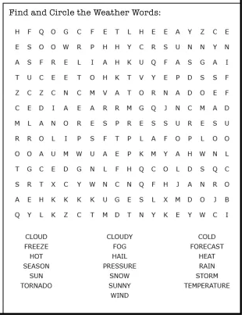
Activity n°2:

