- Materia: Lengua E. “Inglés”
- Profesora: Rodriguez Brea Nahir
- Curso: 1 B
- Bibliografía actual: Unidad 4 Metro Starter (Second Edition)
- Bibliografía a utilizar en el año: Metro Starter (Second Edition)
Material adicional proporcionado por la docente de fuentes como: https://www.liveworksheets.com/es - https://busyteacher.org/https://www.superteacherworksheets.com/index.html- https://www.planitteachers.ai/ Entre otras.
Trabajo Práctico N° 35
HAVE: INTERROGATIVE FORM
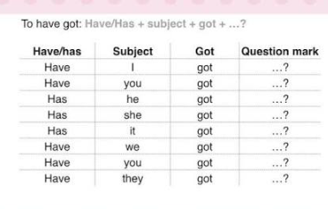
Activity: Read the sentences and complete using “Have or Has”. Then share your answers with your classmates.
- ________ your sister got a bicycle?
- ________ they got any pets?
- ________ you got a pencil in your school bag?
- ________ Tom got a new phone?
- ________ your parents got a car?
- ________ she got long curly hair?
- ________ we got English class today?
- ________ the baby got any teeth?
- ________ your friends got tickets for the concert?
- ________ he got a blue backpack?
- ________ I got the correct answer?
- ________ the students got their books?

