- Materia: Lengua E. “Inglés”
- Profesora: Rodriguez Brea Nahir
- Curso: 2 A
- Bibliografía actual: Unidad 7 y Unit 1 Metro Starter (Oxford) and Metro 1 (Oxford)

- Bibliografía a utilizar en el año: Libro Metro Starter (Oxford) Metro 1 (Oxford)
Material adicional proporcionado por la docente de fuentes como: https://www.liveworksheets.com/es - https://busyteacher.org/https://www.superteacherworksheets.com/index.html- https://www.planitteachers.ai/ Entre otras.
Trabajo Práctico N° 28
CLOTHES AND PHYSICAL DESCRIPTIONS
Theory

General Appearance
- Tall
- Short
- Medium height
- Thin
- Slim
- Fit
- Athletic
- Overweight
- Well-built

Hair
- Long hair
- Short hair
- Straight hair
- Wavy hair
- Curly hair
- Blonde hair
- Brown hair
- Black hair
- Red hair
- Grey hair
- Bald

Eyes
- Blue eyes
- Brown eyes
- Green eyes
- Dark eyes

Face
- Round face
- Oval face
- Square face
- Beard
- Moustache
- Freckles

Age and Appearance
- Young
- Middle-aged
- Good-looking
- Attractive
- Handsome (usually for men)
- Pretty (usually for women)

1.Describe the following people´s appearance
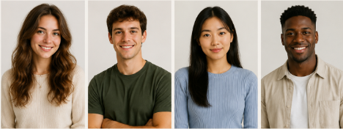
2. Make your presentation to your classmates

