- Materia: Lengua E. “Inglés”
- Profesora: Rodriguez Brea Nahir
- Curso: 2 A
- Bibliografía actual: Unidad 6 Metro Starter (Oxford)

- Bibliografía a utilizar en el año: Libro Metro Starter (Oxford)
Material adicional proporcionado por la docente de fuentes como: https://www.liveworksheets.com/es - https://busyteacher.org/https://www.superteacherworksheets.com/index.html- https://www.planitteachers.ai/ Entre otras.
Trabajo Práctico N° 20
TRABAJO PRACTICO DE REPASO 3/3
GRAMMAR: WH-QUESTIONS, ADVERBS OF FREQUENCY, OBJECT PRONOUNS
Activities:
  - Complete the adverbs of frequency
- A _ _ A _ S
- R _ _E _ Y
- _ E V _ R
- _ F T _ N
- S _ M _ T _ _ E _
  - Order the words to make sentences or questions
- She / English / for / always/ class/ late is
- They / all evening/ watch/ never /TV
- Do/ how/ fast food /often / you/ eat/ ?
- On time / for / always / school / am / I
- Often / forget/ do / your gym clothes / how / you / ?
- Sports / my dad / plays / often
  - How often do you, your family or your friends, do the things below?. Write five sentences. Write about a different person in each sentence
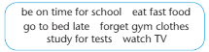

1……………………………………………………………..

2……………………………………………………………..

3………………………………………………………………

4……………………………………………………………..

5……………………………………………………………
  - Wh- questions. Choose the correct words
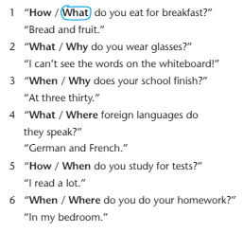
  - Write questions with the words. Then match the questions 1-6 with the answers a-f
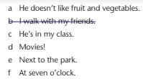
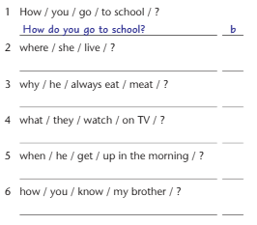
  - Write questions for a friend or a family member with WHY-WHAT- WHERE- WHEN- HOW

