- Materia: Lengua E. “Inglés”
- Profesora: Rodriguez Brea Nahir
- Curso: 1 B
- Bibliografía actual: Unidad 1 Metro Starter (Second Edition)
- Bibliografía a utilizar en el año: Metro Starter (Second Edition)
Material adicional proporcionado por la docente de fuentes como: https://www.liveworksheets.com/es - https://busyteacher.org/https://www.superteacherworksheets.com/index.html- https://www.planitteachers.ai/ Entre otras.
Trabajo Práctico N° 18
TRABAJO PRACTICO DE REPASO N°3/3
GRAMMAR
THERE IS/ARE; IS THERE…? /ARE THERE ANY……?
POSSESSIVE ADJECTIVE
Activities:
- Read and choose
- ……………. there a shower in the bathroom? ARE- IS
- ……………. there any pictures in the living room? ARE-IS
- There …………. Some English books in the bookcase. IS-ARE
- There ………….. a lamp in the dinning room. ISN´T-AREN´T.
- There ………….. some armchairs in the bedroom. IS-ARE
- There …………… a fridge in the kitchen. AREN´T- ISN´T
- Read and match

- Are there……..
- Is there ………
- There aren’t …………
- There are …………
- There is a ………….
- There isn’t ………….

- a stove?
- any lamps?
- Couch.
- some tables.
- any pictures.
- a bed.
- Order the words to make sentences and questions

- any-are-There- books? - English
- a- big- table. - There´s
- There- fridge- a- isn’t
- There´s – bedroom- in- a- my- bookcase
- the- armchairs- any- living room- There- in- aren’t
- Is- the- There- in- a- kitchen? – stove
- Read and choose
IS-ARE
ARE- IS
ARE-IS
AREN’T-ISN’T
IS-ARE
IS-ARE

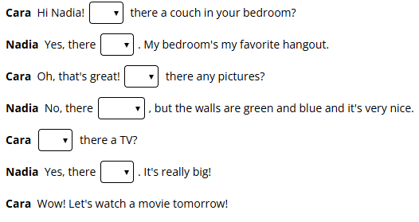
- Possessive adjectives: Complete the sentences with the correct possessive adjective
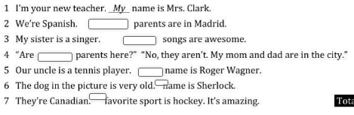
(MY- YOUR-HIS-HER-OUR-THEIR-ITS)

