- Materia: Lengua E. “Inglés”
- Profesora: Rodriguez Brea Nahir
- Curso: 1 B
- Bibliografía actual: Unidad 1 Metro Starter (Second Edition)
- Bibliografía a utilizar en el año: Metro Starter (Second Edition)
Material adicional proporcionado por la docente de fuentes como: https://www.liveworksheets.com/es - https://busyteacher.org/https://www.superteacherworksheets.com/index.html- https://www.planitteachers.ai/ Entre otras.
Trabajo Práctico N° 16
TRABAJO PRACTICO DE REPASO N°1/3
TOPICS FOR THE EXAM:
VOCABULARY:
- School subjects
- Basic adjectives
- Rooms and furniture
- Family
GRAMMAR:
- Be (Affirmative, negative e interrogative)
- Personal Information
- There is-there are, Any
- Possessive adjectives
Activities:
- VOCABULARY:
- Complete the school subjects
- _ A T _
- _ IS _ OR _
- _ C I _ N C _
- _ N G _ I S _
- C _ M _ U T _ R _C I _ N C _
- _ R _
- _ E O _ R A _ H _
B) Basic adjectives: Complete the opposites of the adjectives
1. BIG: ……………..
2. OLD:…………….
3. RIGHT:…………..
4. EASY:……………
C) Rooms and furniture: Look, read and choose
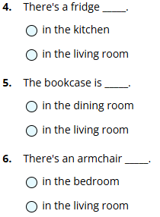
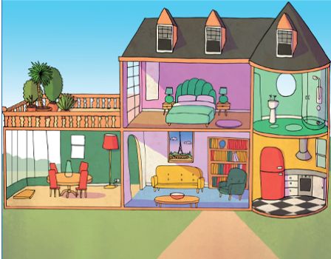
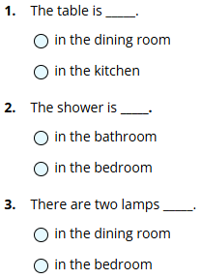
D) Family: Complete the chart with family words:
MASCULINE | FEMININE
BROTHER
 | GRANDMOTHER
FATHER
COUSIN
 | AUNT

Look at the family tree and complete the text with the correct family members
