- Materia: Lengua E. “Inglés”
- Profesora: Rodriguez Brea Nahir
- Curso: 1 A
- Bibliografía actual: Unidad 1 Metro Starter (Second Edition)
- Bibliografía a utilizar en el año: Metro Starter (Second Edition)
Material adicional proporcionado por la docente de fuentes como: https://www.liveworksheets.com/es - https://busyteacher.org/https://www.superteacherworksheets.com/index.html- https://www.planitteachers.ai/ Entre otras.
Trabajo Práctico N° 17
TRABAJO PRACTICO DE REPASO N°2/3
GRAMMAR
Activities:
- Choose the correct form of “be”
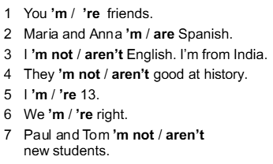
- Complete the sentences. Use the correct affirmative or negative form of be.
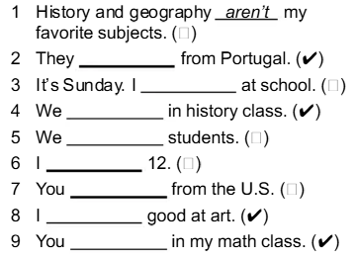

- Rewrite the sentences with the short form of the verbs
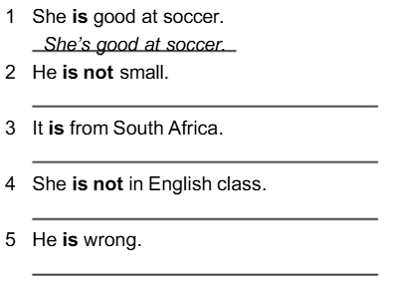
- Read the factfile and complete the text with the correct form of be. Use the short form when possible.
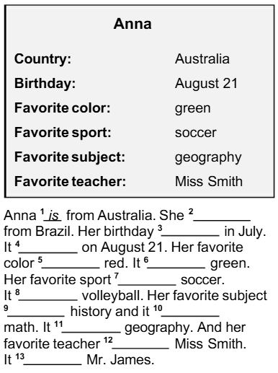
- Complete the questions with the correct form of “be”. Then choose the correct answers.
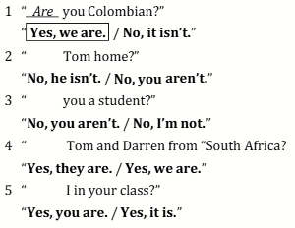

- Information questions: Complete the sentences with question words: WHERE-HOW OLD- WHAT-WHO.

- ……………… is my pencil? –It´s here.
- ……………… ‘s your teacher? – Mrs. Wilson.
- ………………. Is your brother? – He’s 15.
- ……………….is your favourite subject? – English.
- ……………….are your parents from? – Brazil.
- ………………. ‘s your last name? – Williams.

