- Materia: Lengua E. “Inglés”
- Profesora: Rodriguez Brea Nahir
- Curso: 2 A
- Bibliografía actual: Unidad 6 Metro Starter (Oxford)

- Bibliografía a utilizar en el año: Libro Metro Starter (Oxford)
Material adicional proporcionado por la docente de fuentes como: https://www.liveworksheets.com/es - https://busyteacher.org/https://www.superteacherworksheets.com/index.html- https://www.planitteachers.ai/ Entre otras.
Trabajo Práctico N° 10
ADVERBS OF FREQUENCY
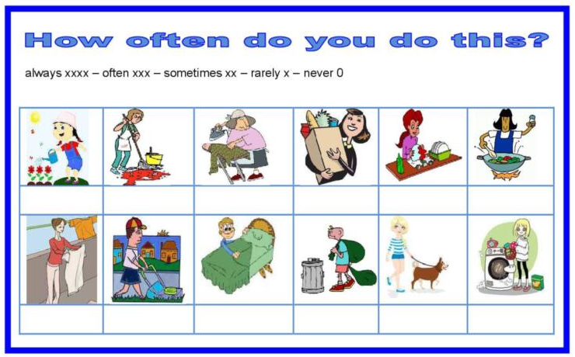
Activity:
- Put the adverb in the right place in the sentence:

- We are happy at class (always)
- Julie and Tom go to the cinema (often)
- Alex is busy at work (twice a week)
- I eat fast food (sometimes)
- They are late for school (usually)
- He is at home (every night)
- You drink coffee (always)
- I go to the park (often)
- They go to a restaurant (sometimes)
- You visit your parents (every Sunday)
- She is friendly (never)

