Materia: LENGUA EXTRANJERA “INGLÉS”
Profesora: CRIPOVICH ABRIL
Curso: 6 año A
Bibliografía: Metro 3 - Oxford
Trabajo Práctico N° 2
Miércoles 11 de marzo
Tema: Taller Inicial Multidisciplinar - “How language shapes how we see the world and nature”
Actividades: Lectura del texto sobre la manera en que los idiomas moldean el modo de ver el mundo y la naturaleza. Puesta en común y debate. Responder preguntas de comprensión lectora.
- Read the text:
HOW LANGUAGE SHAPES HOW WE SEE THE WORLD AND NATURE
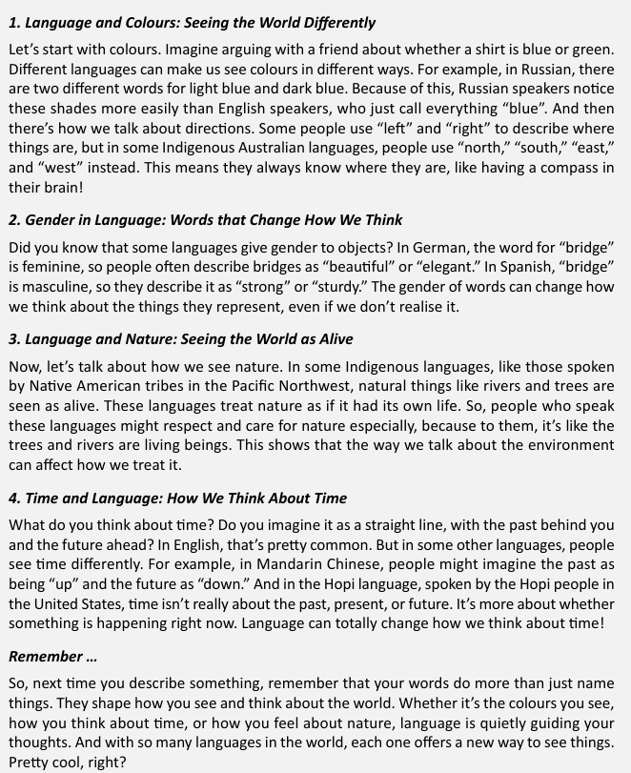
- Answer these questions:
1. Why do Russian speakers notice light blue and dark blue more easily?
2. Which common word do people in Germany use to describe a bridge? Why?
3. How do some Indigenous languages of the Pacific Northwest see rivers and trees?
4. How do many English speakers imagine time?
5. How does language shape our thoughts?
- Decide if the following statements are True (T), False (F), or Not Given (NG) based on the text.
  - Russian speakers are physically able to see more colours than English speakers.
  - Some Australian Indigenous groups do not use the words "left" or "right" for directions. ( )
  - The German language makes people believe bridges are physically weaker than they are in Spain. ( )
  - Languages in the Pacific Northwest treat nature as a collection of objects. ( )
  - In Mandarin Chinese, the future is visually represented as being "below" the past. ( )
- Find words in the text that match the following definitions.
  - Small differences or varieties of a colour: __________
  - Strong and solid; unlikely to break: __________
  - To have a feeling of deep admiration for something/someone: __________
  - Completely or entirely: __________
  - Leading or showing the way: __________
- Complete the sentences using the correct form of the word in brackets.
- The __________ (DIFFER) between how Russians and English speakers see blue is linked to language.
- Learning a new language can change your __________ (PERCEIVE) of time.
- Some tribes have a more __________ (RESPECT) relationship with the environment.
- Many people don't __________ (REALISATION) that their thoughts are shaped by grammar.
- The __________ (BEAUTIFUL) of a bridge might be emphasized more in German than in Spanish.

