- Materia: LENGUA EXTRANJERA “INGLÉS”
- Profesora: RODRIGUEZ BREA NAHIR
- Curso: 4 A
- Bibliografía actual: Libro METRO STARTER (Oxford)
- Bibliografía a utilizar en el año: Libro METRO STARTER (Oxford)- Material adicional proporcionado por la docente de fuentes como: https://www.liveworksheets.com/es - https://busyteacher.org/https://www.superteacherworksheets.com/index.html- https://www.planitteachers.ai/ Entre otras.
TRABAJO PRACTICO DE REPASO INTEGRADOR
1EST TERM
PRESENT SIMPLE VS PRESENT CONTINUOUS
(AFFIRMATIVE, NEGATIVE E INTERROGATIVE FORM)
- Read the text and answer the questions

A Day in Emma’s Life
Emma usually works as a graphic designer in a small marketing company. She creates logos, designs brochures, and often collaborates with the social media team. She loves her job because every project is different.
However, this week things are a bit unusual. The company is preparing a big campaign for an international brand, so Emma is working longer hours than usual. Right now, she is meeting with the project manager to discuss the final details. She is not designing anything at the moment because the team is still deciding on the visual style.
In her free time, Emma usually goes running in the park, but this week she is staying home to rest. She feels a little tired, but she is enjoying the challenge of the new project.

Comprehension Questions
1. What does Emma usually do in her job?
2. Why is this week unusual for Emma?
3. What is Emma doing right now?
4. Why isn’t she designing anything at the moment?
5. What does Emma usually do in her free time?
TRUE OR FALSE: Justify the false ones
6. True or False: Emma hates her job.
7. True or False: The company is preparing an important campaign.
8. True or False: Emma is working fewer hours this week.
9. True or False: Emma is meeting with the project manager now.
10. True or False: She is still going running every day this week.

Grammar: Present Simple vs Present Continuous: Choose the correct option
11. Emma usually ___ (works / is working) as a graphic designer.
12. This week, she ___ (works / is working) longer hours.
13. Right now she ___ (meets / is meeting) with the project manager.
14. She ___ (doesn’t design / isn’t designing) anything at the moment.
15. She usually ___ (goes / is going) running in the park.

2nd TERM
COMPARATIVE VS SUPERLATIVE ADJECTIVES|BE GOING TO
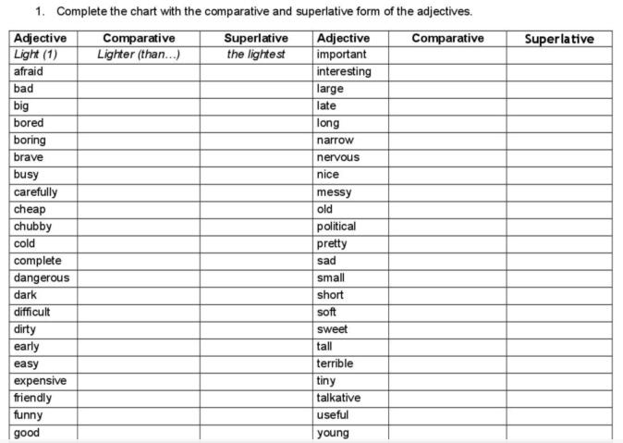

- Read and complete the sentences using the comparative vs superlative form
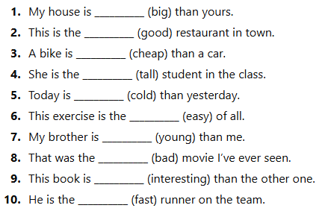

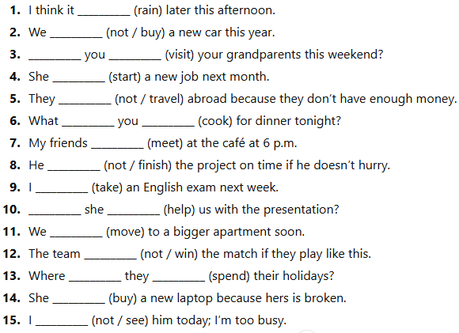
- Read and complete the sentences using the corresponding “be going to form”

3rd TERM
PAST SIMPLE VS PAST CONTINUOUS FORM
Last Saturday, Emma was walking home from work when something unusual happened. As she was crossing the park, she noticed a small dog that was running in circles near a bench. It seemed scared and lost. While Emma was trying to get closer, the dog suddenly ran away and disappeared behind some trees.
Emma decided to follow it. While she was looking for the dog, she heard someone calling, “Milo! Milo!” An old man was standing near the fountain and was shouting the dog’s name repeatedly. Emma approached him and asked if he was looking for a small brown dog. The man nodded quickly and explained that the dog had escaped while he was feeding the birds.
A moment later, the dog appeared, still shaking, but it ran straight into the man’s arms. He thanked Emma for her help and told her that Milo often got nervous when there were too many people around. Emma smiled, relieved that the situation ended well, and then she continued her walk home.
Questions:
- What was Emma doing when she noticed the dog?
- Why did Emma decide to follow the dog?
- What was the old man doing when the dog ran away?
- How did the old man react when Emma spoke to him?
- Why does Milo often get nervous?
- What actions in the story show Past Continuous? Name at least three.
- What event interrupted an action in progress?
- Do you think Emma behaved responsibly? Why or why not?
2. Read and complete the sentences using the past simple vs past continuous form
- I __________ (walk) to school when it suddenly __________ (start) to rain.
- She __________ (cook) dinner when the phone __________ (ring).
- They __________ (not hear) the alarm because they __________ (sleep).
- While we __________ (watch) the movie, the lights __________ (go out).
- He __________ (break) his arm while he __________ (play) football.
- I __________ (see) her yesterday while she __________ (wait) for the bus.
- The students __________ (study) when the teacher __________ (enter) the classroom.
- She __________ (drop) her keys while she __________ (run) to catch the train.
- We __________ (not talk) because everyone __________ (listen) to the speaker.
- What __________ you __________ (do) when the accident __________ (happen)?
- They __________ (walk) in the park when they __________ (find) a lost wallet.
- He __________ (not notice) me because he __________ (look) at his phone.
- While I __________ (clean) the house, my sister __________ (finish) her homework.
- The dog __________ (bark) loudly while the neighbours __________ (try) to sleep.
- She __________ (meet) her best friend while she __________ (travel) in Spain.

