- Materia: LENGUA EXTRANJERA “INGLÉS”
- Profesora: RODRIGUEZ BREA NAHIR
- Curso: 1 A y B
- Bibliografía actual: Libro METRO STARTER (Oxford)
- Bibliografía a utilizar en el año: Libro METRO STARTER (Oxford)- Material adicional proporcionado por la docente de fuentes como: https://www.liveworksheets.com/es - https://busyteacher.org/https://www.superteacherworksheets.com/index.html- https://www.planitteachers.ai/ Entre otras.
TRABAJO PRACTICO DE REPASO INTEGRADOR
1EST TERM
PERSONAL INFORMATION | VERB TO BE (AFFIRMATIVE, NEGATIVE E INTERROGATIVE FORM)
- Read the text and complete it using your personal information
Hi! My name is ______. I am ______ years old and I am from ______. I live in ______ with my family. I have ______ brothers and ______ sisters. My birthday is on ______.
I am a student at ______ School. My favourite subject is ______. In my free time, I like ______ and ______. My favourite food is ______. I speak ______ and I’m learning English.
My phone number is ______ and my email is ______. My best friend is ______. We usually ______ after school.
- Read the sentences and complete them using the verb to be in its corresponding form
- I ______ a student.
- She ______ not my sister.
- ______ you from Brazil?
- My parents ______ very friendly.
- He ______ not at home today.
- ______ this your book?
- We ______ in the classroom now.
- The dog ______ very big.
- ______ they your friends?
- I ______ not tired.
- This ______ my favorite color.
- ______ she your English teacher?
- They ______ not in the garden.
- You ______ very good at English!
- ______ we late for the lesson?
2ND TERM
VERB “LIKE” AND “HAVE” EN PRIMERA Y TERCERA PERSONA
(AFFIRMATIVE, NEGATIVE E INTERROGATIVE FORM)
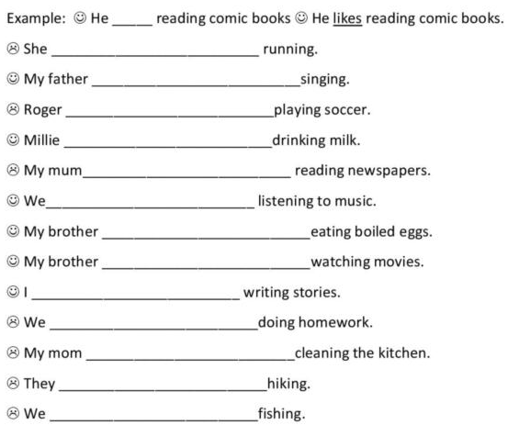
- Fill in the blanks with “like, likes, don’t like or doesn’t like”

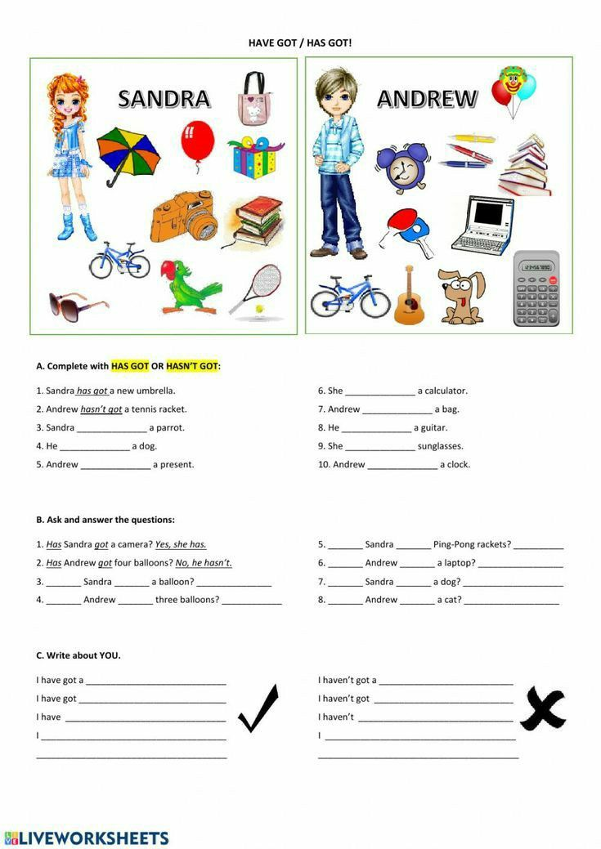
2,

3RD TERM
VERB “CAN” AND “CAN´T ”| POSSESSIVE ´S| PRESENT SIMPLE
(AFFIRMATIVE, NEGATIVE E INTERROGATIVE FORM)
- Look at the chart and complete the sentences with “CAN” or “CAN´T”
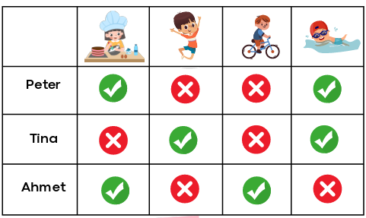

1.Peter …………. cook
2. Tina ……………. jump but she …………. ride a bike
3.Tina ……………… ride a bike
4.Ahmet …………… swim but he ………………cook.
5.Ahmet ………………… swim
6.Peter and Tina……………… ride a bike.
7. Peter and Tina ……………. Swim
8. Tina ……………jump but Peter ……………
9. Peter and Ahmet ……………… jump
10.Tina……………cook but Ahmet ……….
- Rewrite each of the following sentences with the possessive apostrophe

  - The book of Maria → …………………………………………………………………………………..
  - The pencil of the teacher → ………………………………………………………………………..
  - The dog of my brother → …………………………………………………………………………….
  - The bag of the student → ……………………………………………………………………………
  - The shoes of Ana → ……………………………………………………………………………………..
  - The car of my father → ………………………………………………………………………………..
  - The house of my grandparents → ………………………………………………………………..
  - The phone of Lucas → ………………………………………………………………………………….
  - The keys of my mother → …………………………………………………………………………….
J. The computer of the school → ……………………………………………………………………..
- Read and complete the sentences using the corresponding present simple form.
AFFIRMATIVE
- She __________ (go) to the gym every morning.
- My brother ____________ (study) engineering at university.
- They ___________ (live) near the beach.
- The train __________ (leave) at 6:45 a.m.
- He __________ (play) the guitar in a band.
- Our teacher ________________ (explain) grammar very clearly.
- I ___________ (drink) coffee before work.
- The store __________ (open) at nine o’clock.
- My parents __________ (travel) every summer.
- The dog ___________ (sleep) in the garden.
NEGATIVE
  - She _______________(not/like) spicy food.
  - I ___________________ (not/understand) this exercise.
  - He ______________ (not/drink) tea in the morning.
  - They ___________ (not/play) tennis on weekdays.
  - The company _______________ (not/offer) discounts in winter.
  - We _____________ (not/eat) meat.
  - My friend _______________ (not/drive) to school.
  - The museum ________________ (not/ open) on Mondays.
  - I ____________ (not/have) classes on Friday afternoons
10. She _______________ (not/watch) TV at night.

