Materia: E.D.I (ESPACIO DE DEFINICIÓN INSTITUCIONAL) Curso: 4do año
Profesor: Roberto Jorge Romero
Trabajo Práctico N° 53
Presentación de carpetas 03/11, 07/11, 10/11
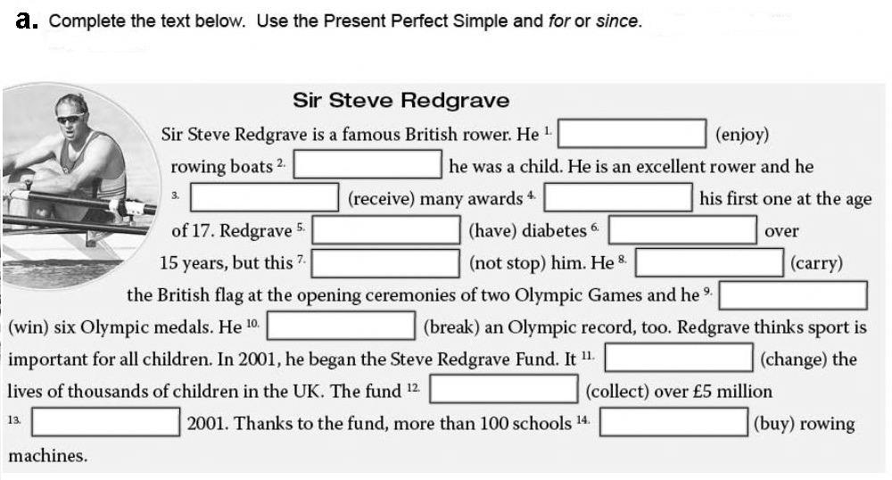
b. Answer
- Has Steve Redgrave received many awards?
- Has he had diabetes?
- What has he carried in the Olympic Games?
- How many medals has he won?
c. underline all verbs
d. translate

