Materia: E.D.I (ESPACIO DE DEFINICIÓN INSTITUCIONAL) Curso: 4do año
Profesor: Roberto Jorge Romero
Trabajo Práctico N° 57
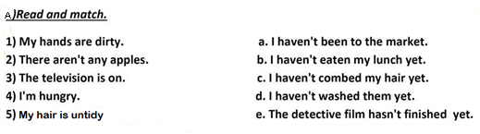
b. Write the participle form of the following verbs.
- go →
- sing →
- be →
- buy →
- do →
- break→
- choose→
- forget→
- dream→
- understand→

c. Complete the table in present perfect simple.

positive | negative | question
1 He has written a letter.
 | 2 They have not stopped
 |  | 3 Have we danced?
4 She has worked.
 | 5 Andy has not slept

- Write sentences in present perfect simple.

- they / ask / a question -
- he / speak / English -
- I / be / in my room -
- we / not / wash / the car -
- Annie / not / forget / her homework –

d. Write questions in present perfect simple.

- they / finish / their homework -
- Sue / kiss / Ben -
- the waiter / bring / the tea -
- Marilyn / pay / the bill -
- you / ever / write / a poem -

