Materia: E.D.I (ESPACIO DE DEFINICIÓN INSTITUCIONAL) Curso: 3er año
Profesor: Roberto Jorge Romero
Trabajo Práctico N° 49

Pronombres indefinidos
Los pronombres indefinidos no se refieren a una persona, lugar o cosa específicos. En inglés, existe un grupo particular de pronombres indefinidos formados por un cuantificador o distributivo precedido por any, some, every y no.
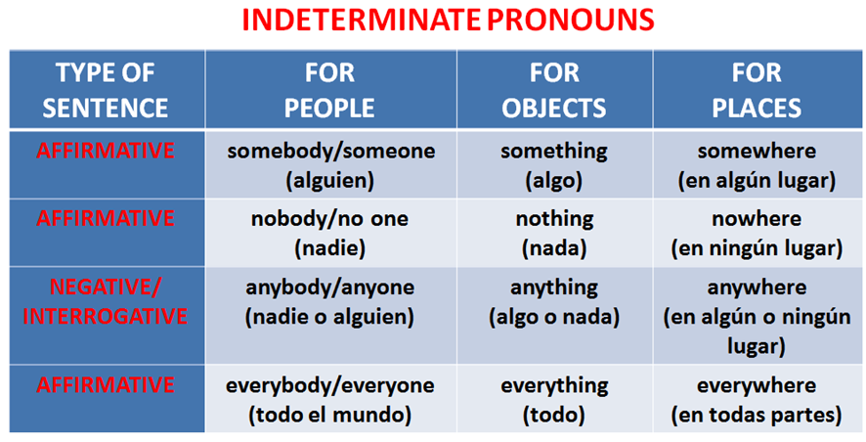
- Choose the correct answer.
Would you like something/everybody to eat?
It was really dark and I couldn't see anything/something.
Does anybody/nobody live in that house?score
It doesn't matter where we go, We can go anywhere/anything we want to.
This is boring. There's nothing/everything to do.
The shop is closed. Everybody/something has gone home.
The guidebook says there's a good hotel somewhere/anywhere near here.

- Complete the sentences using the words from the box.

ANYONE - ANYTHING – ANYWHERE – EVERYBODY –
NOBODY - SOMEONE
1. Do you have ________________ in your coat pocket? – Let's see.
2. Jonathon is speaking to ________________ on the phone.
3. Aimee didn't tell her secret to ________________.
4. The headmaster is very popular at school. ________________ likes him.
5. My boyfriend likes to be at home. He doesn't want to go _____________ after dark.
6. The room was empty. There was ________________ to talk to.

