Materia: E.D.I (ESPACIO DE DEFINICIÓN INSTITUCIONAL) Curso: 3er año
Profesor: Roberto Jorge Romero
Trabajo Práctico N° 45

Continuamos copiando y explicando
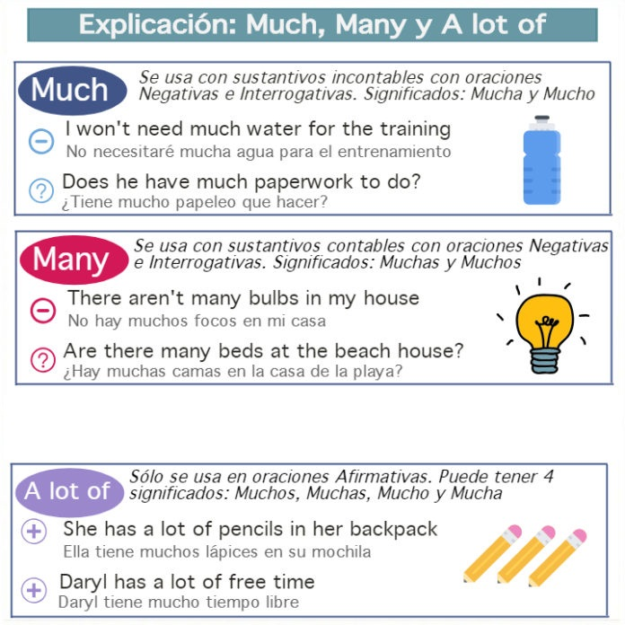
- Complete with A LOT OF, MANY OR MUCH
- They had __________ accidents this year.
- I don´t like to drink __________ beer.
- I don’t need __________ toothpaste.
- Does she buy __________ Christmas trees?
- Do you need __________ pens for the meeting?
- Do you know if Ralph has __________ brothers and sisters?
- Dou you want __________ sugar with your coffee?
- I bought __________ books yesterday.
- I don't have __________ money

