- Materia: LENGUA EXTRANJERA “INGLÉS”
- Profesora: RODRIGUEZ BREA NAHIR
- Curso: 1 A
- Bibliografía actual: Libro METRO STARTER (Oxford)
- Bibliografía a utilizar en el año: Libro METRO STARTER (Oxford)- Material adicional proporcionado por la docente de fuentes como: https://www.liveworksheets.com/es - https://busyteacher.org/https://www.superteacherworksheets.com/index.html- https://www.planitteachers.ai/ Entre otras.
Trabajo Práctico N° 26
III TERM
CAN-CAN´T| POSSESIVE´S
Activity:
The student´s will solve a practice test, regarding two grammar topics seen in class.
CAN- CAN´T
- Look the information and say what the robot CAN or CAN´T do (5 pts)
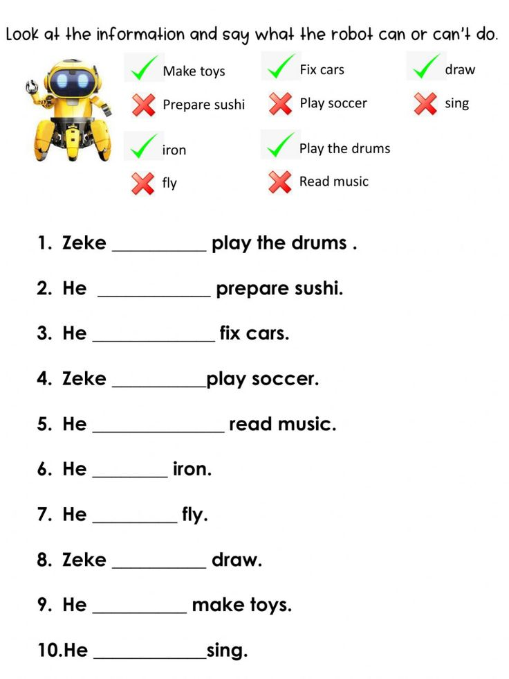

- Zecke ………………play the drums
- He ………………. prepare sushi
- He……………….. play soccer
- He ………………. Iron
- He ………………… draw
- He …………………. Sing
- He ……………….. fix cars
- He …………………. Sing
- He ………………….. read music
- He ………………… fly

- Look at the table and complete the sentences using “Can or Can´t” (6 pts)
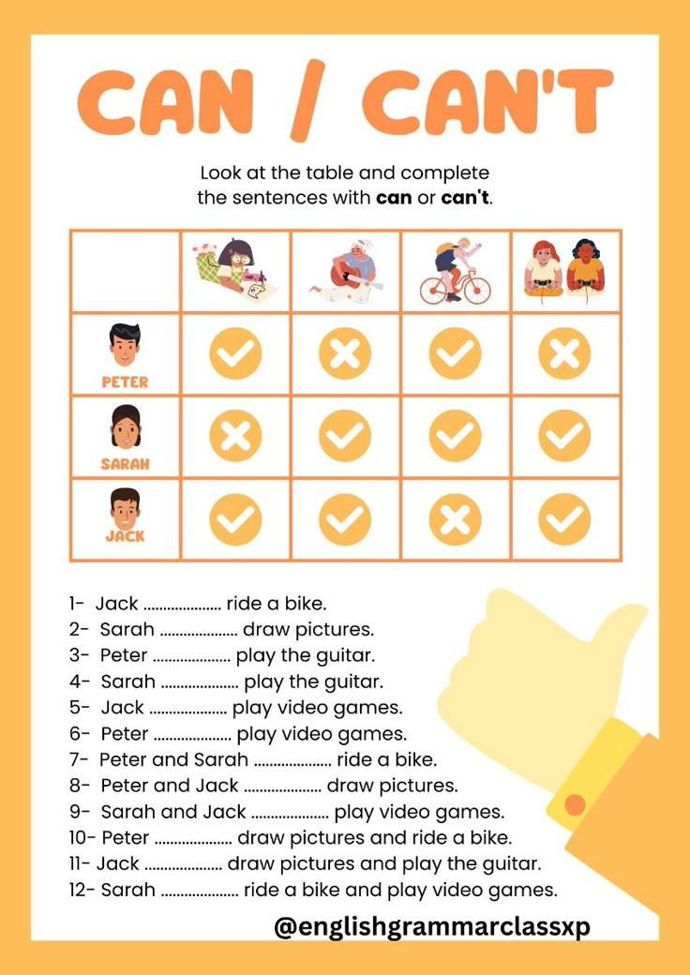

- Rewrite each of the following sentences with the possessive apostrophe
(10 pts)
Example: The book of John John´s book

- The son of Mr. Smith : ………………………………………………………….
- The daughter of Miss Anto: …………………………………………………….
- The lesson of Kate: ………………………………………………………………….
- The toys of children : ……………………………………………………………….
- The cage of the dog : ………………………………………………………………….
- The book of the students: …………………………………………………………..
- The treasure map of the pirate :…………………………………………………………….
- The books of the library :………………………………………………………………………
- The bike of James :…………………………………………………………………………………
- The speech of the president: ………………………………………………………………..

