Materia: E.D.I (ESPACIO DE DEFINICIÓN INSTITUCIONAL) Curso: 2do año

Profesor: Roberto Jorge Romero

**Trabajo Práctico N° 15**

1. Complete the chart regular verbs and irregular verbs

|  |  |
| --- | --- |
| Infinitive form | Past simple |
| 1. Buy |  |
| 1. see |  |
| 1. eat |  |
| 1. Swim |  |
| 1. stop |  |
| 1. drive |  |
| 1. Do |  |
| 1. Fly |  |
| 1. have |  |
| 1. study |  |
| 1. Write |  |
| 1. Visit |  |



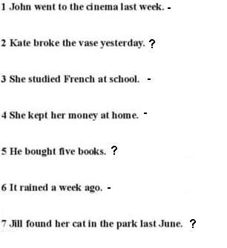

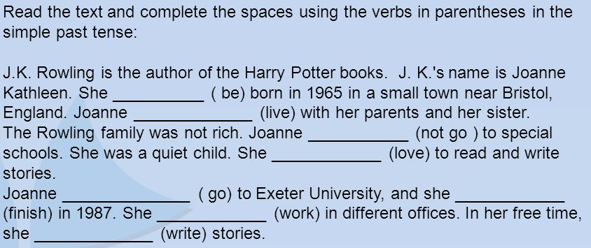

Answer

1. Who was the author of Harry Potter books?
2. Did she go to special school?
3. When did she finish the university?
4. What did she do in her free time?