* **Materia:** LENGUA EXTRANJERA “INGLÉS”
* **Profesora:** RODRIGUEZ BREA NAHIR
* **Curso:** 6 A
* **Bibliografía actual:** Libro METRO 3 (Oxford)
* **Bibliografía a utilizar en** **el año:** Libro METRO 3 (Oxford)- Material adicional proporcionado por la docente de fuentes como: <https://www.liveworksheets.com/es> - <https://busyteacher.org/><https://www.superteacherworksheets.com/index.html-> <https://www.planitteachers.ai/> Entre otras.

**Trabajo Práctico N° 16**

**Fecha: 2nd July ,2025**

***SECOND CONDITIONAL PRACTICE TEST***

Activity n°1: **Choose the correct verb tense in each of the following sentences**

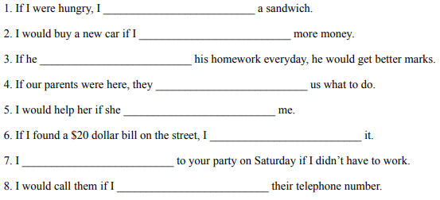

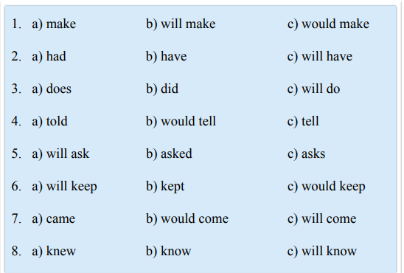

Activity n°2: **Complete the following sentences using the correct form of the verb provided.**

1. It’s Monday today, but if it ___________________ (be) Saturday, I ______________________ (go) to the beach.

2. I don’t have any money now, but if I ___________________ (have) some, I _________________ (lend) it to you.

3. I have to work tomorrow, but if I ___________________ (be) free, I ___________________ (go) shopping with you.

4. Amy can only speak one language, but if she ________________ (can) speak two languages, she ___________________ (apply) for a job at the Multicultural Center.

5. Sue doesn’t know how to knit. If she ___________________ (know) how to knit, she ____________________ (make) a sweater for you for your birthday.

6. I don’t own a pair of skis. If I ________________ (have) skis, I __________________ (go) skiing with you tomorrow.

7. I can’t understand what he’s saying. If he ___________________ (speak) more clearly, I ____________________ (understand) more.

8. We are not going to buy that house, but if it ______________________ (be) a little cheaper, we ____________________ (buy) it.

9. He is not going to pass his exam. If he ______________________ (study) harder, he _____________________ (pass).

10. John has a lot of car accidents. If he _____________________ (drive) more carefully, he _______________________ (have) fewer accidents.

11. Beth eats a lot of junk food. If she _____________________ (eat) healthier food, she ____________________ (lose) weight.

12. Robert smokes a lot. If he ______________________ (quit) smoking, his cough _______________ (get) better.

Activity n°3: **Find the mistakes in the second conditional sentences and write the correct word on the right.**

1. What would you do if you would see a big spider in your bed? _______________
2. If I spilled orange juice on my English homework, I will be upset. ________________
3. Did you explore a desert island If you were alone on it? ________________
4. What did you do if I forgot your birthday? _______________
5. Would Adam come to the party If we would send him an invitation? _______________
6. If I lived not far from you, we can walk to school together. ______________
7. If you have a special power, what would you be able to do? __________________
8. Which one item would you rescue if your house is on fire? ___________________