Materia: E.D.I (ESPACIO DE DEFINICIÓN INSTITUCIONAL) Curso: 6to año

Profesor: Roberto Jorge Romero

**Trabajo Práctico N° 32**

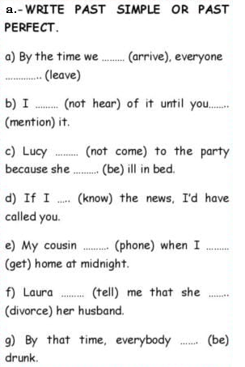

b. write the meaning

1. break down:

2. throw away :

3. forget about:

4. look for:

c. Write the sentence with the correct phrasal verb

1. My husband wants the money to ______________ my car.
2. all you can do is ______________ and wait.
3. You can't ______________ with this guy 'cause he's married.
4. What if we don't ________________ your way.