* **Materia:** LENGUA EXTRANJERA “INGLÉS”
* **Profesora:** RODRIGUEZ BREA NAHIR
* **Curso:** 3 A
* **Bibliografía actual:** Libro METRO 1 (Oxford)
* **Bibliografía a utilizar en** **el año:** Libro METRO 1 (Oxford)- Material adicional proporcionado por la docente de fuentes como: <https://www.liveworksheets.com/es> - <https://busyteacher.org/><https://www.superteacherworksheets.com/index.html-> <https://www.planitteachers.ai/> Entre otras.

**Trabajo Práctico N° 33**

**FOOD COUNT AND NON-COUNT NOUNS**

**THERE IS-THERE ARE, SOME, A-AN, ANY**

**PRACTICE TEST**

1. **Complete the chart, using the food vocabulary provided.**

**MILK- STRAWBERRY- WATER- OLIVE OIL- LEMON- ORANGE JUICE- CHEESE- CHERRY-MANGO- PEAR-TOMATO-SOUP- HONEY- APPLE- PEACH-BUTTER-LEMONADE –BURGER- BREAD- PASTA- CUP OF TEA-BOTTLE OF MILK- SUGAR- TEA- EGGS**

|  |  |
| --- | --- |
| **COUNTABLE** | **UNCOUNTABLE** |
|  |  |
|  |  |
|  |  |
|  |  |
|  |  |
|  |  |
|  |  |
|  |  |
|  |  |
|  |  |
|  |  |
|  |  |
|  |  |
|  |  |

1. **Read and complete the sentences, using THERE IS/ISN´T- THERE ARE/AREN´T**
2. ___________ some salt.
3. ___________ any coffee.
4. ____________some meat.
5. ____________ two carrots.
6. _____________any tomatoes.
7. _____________some water.
8. _____________three eggs.
9. _____________an apple tree.
10. _____________some cheese.
11. _____________ any sugar.
12. _____________some snacks.
13. _____________ a lemon.
14. _____________ any biscuits.
15. _____________an orange.
16. **Complete using the right option: SOME- A- ANY or AN**
17. There is________ milk.
18. There aren’t ________ apples
19. Is there ___________ orange?
20. There are ___________ carrots.
21. There is __________meat.
22. There isn’t __________ coffee.
23. There is ___________ apple tree.
24. There isn’t __________ rice.
25. There is ____________ watermelon.
26. Are there ____________ tomatoes?

**Nina is making an omelette for the first time. She asks her mother Marian who is watching TV.**

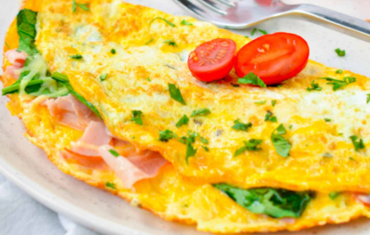**C.1 Complete the dialogue with SOME or ANY.**

Nina: Mother! Are there __________ eggs?

Marian: Yes, there are ____________ in the cupboard.

Nina: Is there _____________ cheese?

Marian: Yes, there´s _________ in the fridge.

Nina: Can I use _______olive oil?

Marian: Yes, of course.

Nina: I need ___________ tomatoes.

Marian: There aren’t ____________ Nina. Would you like me to help you?

Nina: No, thanks, I´m OK