Materia: E.D.I (ESPACIO DE DEFINICIÓN INSTITUCIONAL) Curso: 3 año

Profesor: Roberto Jorge Romero

**Trabajo Práctico N° 29**

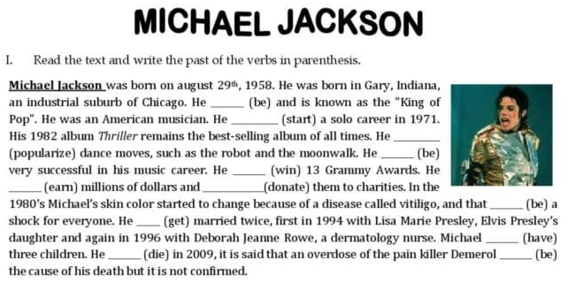

2 Answers

1. When was Michael Jackson born?
2. Did he star a solo career in 1972?
3. What did he popularize?
4. How many times did he marry?
5. What happened with his skin?, Why?
6. When did he die?