Materia: E.D.I (ESPACIO DE DEFINICIÓN INSTITUCIONAL) Curso: 2do año

Profesor: Roberto Jorge Romero

**Trabajo Práctico N° 13**

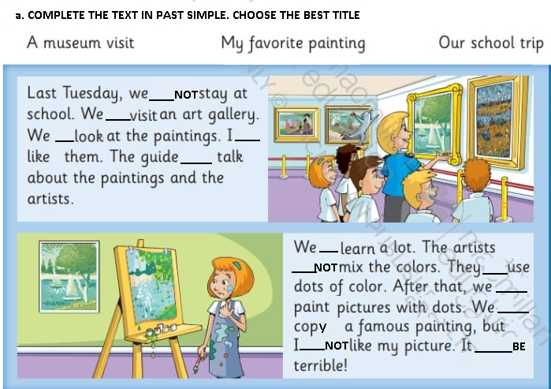

b.ANSWER

1. DID THEY VISIT AN ART GALLERY?
2. WHEN DID THEY GO TO THE ART GALLERY?
3. DID THE ARTIST MIX THE COLOR?
4. WHAT DID THEY USE TO PAINT THE PICTURE?