Materia: E.D.I (ESPACIO DE DEFINICIÓN INSTITUCIONAL) Curso: 2 año

Profesor: Roberto Jorge Romero

**Trabajo Práctico N° 12**

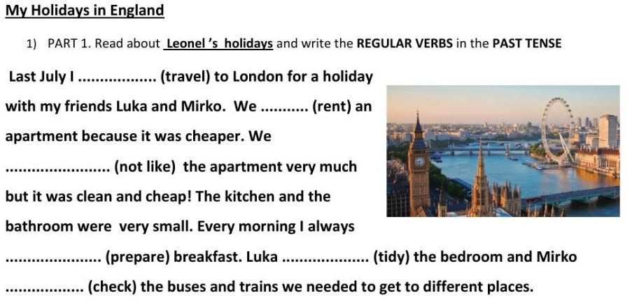

Answer

1. Did Leonel travel to London?
2. Did he travel with Mark and Michael?
3. Why did they rent an apartment?
4. Did Leonel always prepare lunch?