Materia: E.D.I (ESPACIO DE DEFINICIÓN INSTITUCIONAL)

Profesor: Roberto Jorge Romero

Curso: 6 año

**Trabajo Práctico N°**

**2 trimestre**

* Past perfect vs past simple (affirmative, negative and interrogative)
* Verbs infinitive, past, past participle
* Phrasal verbs

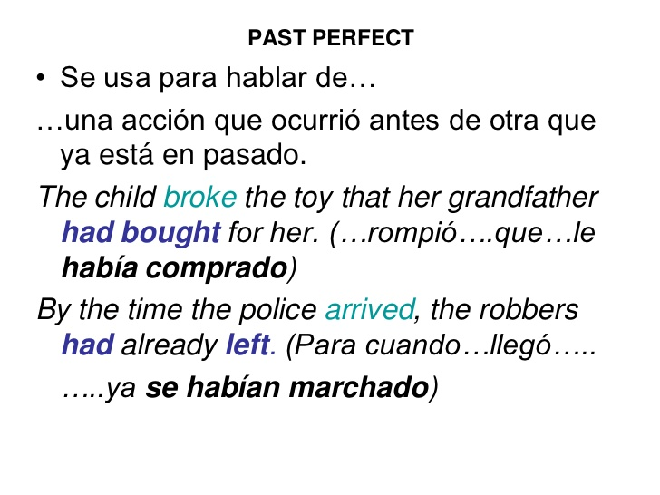

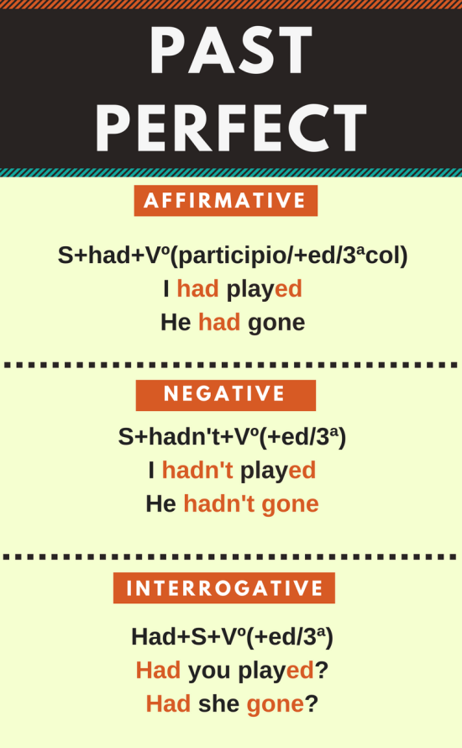

1. Write the conjunction for these verbs.

|  |  |  |
| --- | --- | --- |
| Infinite verb | Past simple | Past participle |
| 1. Go |  |  |
| 1. Write |  |  |
| 1. Stay |  |  |
| 1. Said |  |  |
| 1. Jump |  |  |
| 1. Cry |  |  |
| 1. Fly |  |  |

1. Write the verbs in the past simple or past perfect, as appropriate.

1 My brother (have) _______ an stomachache after he (eat) _______ all the cake.

2 Her mother (die) ________ last year but she (be) _______ disabled in the last three years.

3 Last night I (go) _________ for a walk after I (finish) ________ my work.

4 Lucy (refuse) _________ the offer after they (interview) ________ her twice.

5 The teacher (not award) ________ his student with a high mark because he (not work) _________ very hard.

6 Henry (come) ________ home from holidays and (discover) _________ someone (break) ________ into his house.

7 Laura (be) _________ furious with her son Tom because he (not do)_________ his homework.

8 When I (see) _______ him, he (be) ________ shaking because he (be) _______ swimming.

9 I (phone) _________ the embassy to ask why my passport (arrive) _________ yet.

10 Dinner (be) ________ wonderful, Donald (cook) ________ a mushroom risotto.