* **Materia:** LENGUA EXTRANJERA “INGLÉS”
* **Profesora:** RODRIGUEZ BREA NAHIR
* **Curso:** 5 A
* **Bibliografía actual:** Libro METRO 3 (Oxford)
* **Bibliografía a utilizar en** **el año:** Libro METRO 3 (Oxford)- Material adicional proporcionado por la docente de fuentes como: <https://www.liveworksheets.com/es> - <https://busyteacher.org/><https://www.superteacherworksheets.com/index.html-> <https://www.planitteachers.ai/> Entre otras.

**Trabajo Práctico N° 27**

**Fecha: 23rd June, 2025**

**ZERO CONDITIONAL PRACTICE TEST**

1. **Underline the correct Zero Conditional verb form in the sentences below.**
2. If I don’t get / not get enough sleep, I am / be grumpy the next day.
3. When I get / will get home in the evening, I walk / walked the dog.
4. Our hearts beat / beats faster when we exercise / will exercise.
5. Llamas spit / spits when they are / be angry.
6. If I don’t have / won’t have plans at the weekend, I stay / stayed in and clean the house
7. **Match the sentence halves with their correct endings, putting the verbs in the Zero Conditional form.**

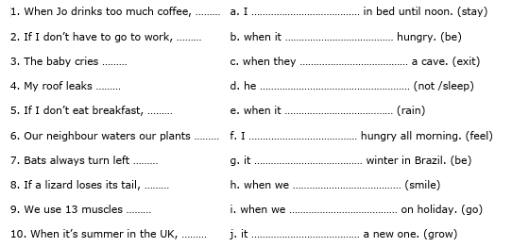

1. **Complete the Zero Conditional sentences using one of the verbs in the box on the left in the correct form and one of the nouns in the box on the right.**



1. If I …………………………………………… a lot of spicy food, I get a ……………………………………………………

2. Milk goes off if you ………………………………………… it in the ……………………………………………………

3. Tom …………………………………………… more ……………………………………………… if he works overtime.

4. My ……………………………………… looks messy when I …………………………………………………………… it.

5. Most ………………………………………… ………………………………………… white when they get married.