Materia: E.D.I (ESPACIO DE DEFINICIÓN INSTITUCIONAL) Curso: 4 año

Profesor: Roberto Jorge Romero

**Trabajo Práctico N° 28**

Lo primero que debes saber es que will es un auxiliar, también conocido como verbo modal. Esto quiere decir que nos valemos de él para crear una forma del verbo, en este caso, el futuro.

* Usa will para expresar una decisión instantánea.
* Usa will para hacer predicciones
* Usamos will para promesa
* Usamos will para reusarse a hacer algo

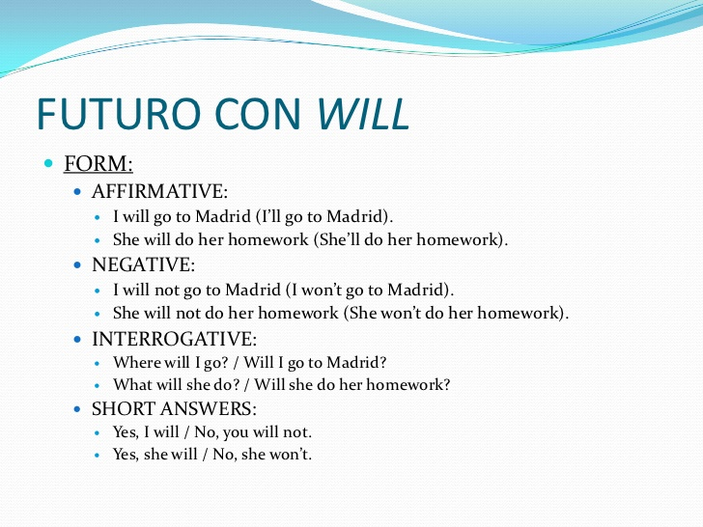

1. Escribe oraciones afirmativas en future simple (will).
2. (I/do/this/later) _____________________________
3. (we/go shopping) ____________________________
4. (the sun/shine) ______________________________
5. (Peter/call/you) ______________________________
6. (they/be/there) ______________________________
7. Completa las oraciones con future simple (will).
8. It (rain/not) ______________________________ tomorrow.
9. I promise I (be/not) _______________________ late.
10. We (start/not) _______________________ to watch the film without you.
11. The bus (wait/not) ____________________ for us.
12. He (believe/not) ______________________ us.
13. Formula oraciones interrogativas en future simple (will).
14. (what/learn/they) __________________________?
15. (it/snow) ___________________________?
16. (when/you/get/home) ______________________________?
17. (she/forgive/me) _______________________________?
18. (what/say/he) ___________________________?

D. LLena los espacios con will o won´t

1. You are late. You _______ arrive on time.
2. The sodas are getting hot. I....................... put them in the freezer.
3. Tom .................. probably get that important job.
4. I ..................... help you today because I’m too busy.
5. Put on your coat or you ................... get cold.
6. I think I ................... have time to go shopping with you next Saturday.

I’m sorry.

1. It’s Freddy’s birthday next week. I ................... send him a birthday card.
2. My mom is very tired. I think she .................. cook dinner tonight
3. It’s very hot today. I ................... open the window.
4. I ...................... eat my sandwich now. I need to call my father first.