Materia: E.D.I (ESPACIO DE DEFINICIÓN INSTITUCIONAL) Curso: 4 año

Profesor: Roberto Jorge Romero

**Trabajo Práctico N° 24**

**Copiar en la carpeta con letra grande y color**

**2 trimestre**

* Future – be going to (affirmative, negative and interrogative)
* Will (affirmative, negative and interrogative)
* Will and be going to
* Gerunds – verb + ing

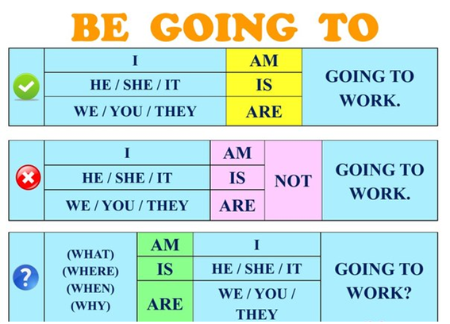

* **BE GOING TO LO USAMOS PARA PREDICCION BASADO EN EVIDENCIA Y PLANES**
* Look the sky. The clouds are black. It **is going to** rain.
* I need to by some flour. I **am going to** make pizza tonight.

1. Choose the correct one

**A**

1. He are going to buy a car.
2. He am going to buy a car.
3. He is going to buy a car.

**B**

1. I are going to cook a meal.
2. I am going to cook a meal.
3. I is going to cook a meal.

**C**

1. We is going to have a drink.
2. We are going to have a drink.
3. We am going to have a drink.

**D**

1. We are going to go out for a walk.
2. We am going to go out for a walk.
3. We is going to go out for a walk.
4. Complete the sentences use **be going to**

01) The farmer _________ (plow) his field in September.

02) I ______________ (work) next summer.

03) Lynn ___________ (visit) her friend.

04) We ___________ (clean) our apartment tomorrow.

05) The students ____________ (study) MATHS.

06) John ____________ (take) the dog to the park.

07) The monkey ____________ (jump) off the tree.

08) The girls _____________ (catch) the balls.

09) The water ____________ (spill) on the floor.

10) It ____________ (snow) in December.

3. Then make 5 negatives and 5 interrogatives