Materia: E.D.I (ESPACIO DE DEFINICIÓN INSTITUCIONAL) Curso: 3 año

Profesor: Roberto Jorge Romero

**Trabajo Práctico N° 10**

Copiar en la carpeta con letra grande y color

2 trimestre

* Past simple (positive, negative and question) regular, irregular form
* Countable and uncountable nouns

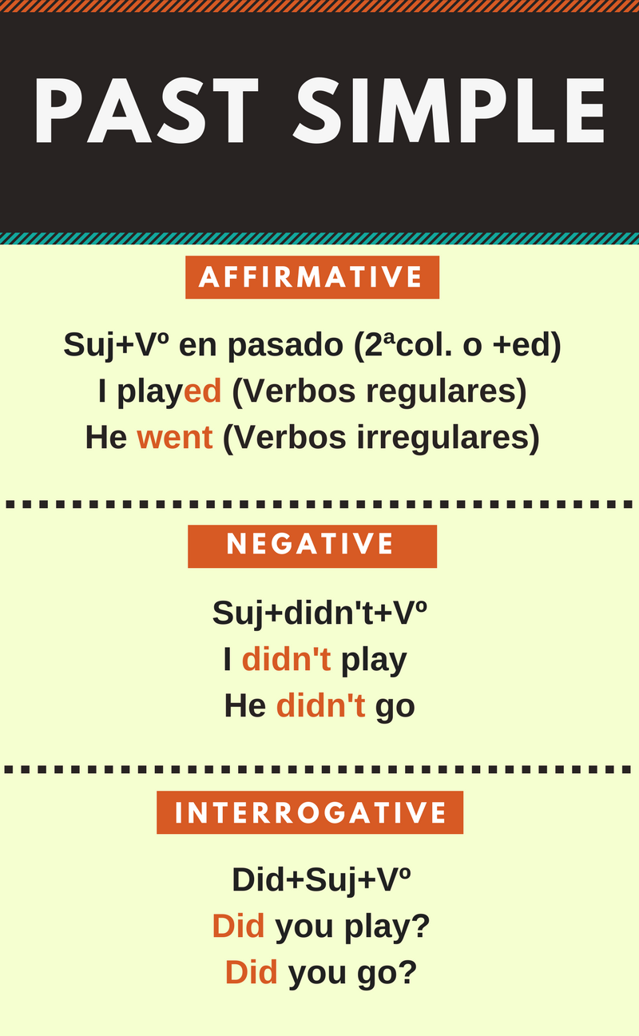

Ejercicio 1. Selecciona las formas correctas del Past Simple y tachalas incorrectas.

~~writed~~

sended

met

stopped

taked

buyed

stoped

ate

wrote

gave

sent

saw

gived

meeted

eated

did

spent

took

bought

finded

left

brought

asked

found

leaved

ejercicio 2. Completa la tabla con la forma correcta de los verbos anteriores y su infinitivo correspondiente.

|  |  |
| --- | --- |
| Verbos irregulares | Verbos regulares |
| 1 buy, bought |  |
| 2 |  |

|  |
| --- |
| 3 |
| 4 |
| 5 |
| 6 |
| 7 |
| 8 |
| 9 |
| 10 |

|  |
| --- |
| 11 |
| 12 |
| 13 |