Materia: E.D.I (ESPACIO DE DEFINICIÓN INSTITUCIONAL) Curso: 2 año

Profesor: Roberto Jorge Romero

**Trabajo Práctico N° 10**

Copiar en la carpeta con letra grande y color

**2 trimestre**

* Past simple regular verbs (affirmative)
* Past simple irregular verbs (affirmative)
* Past simple (affirmative, negative and interrogative)
* Question words past simple
* Preposition of place

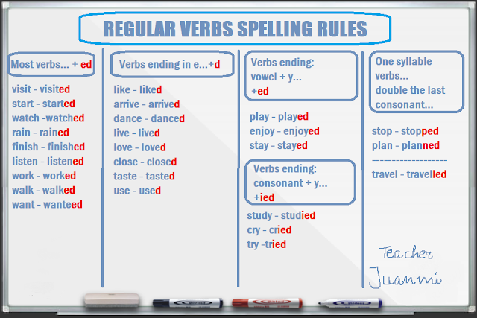

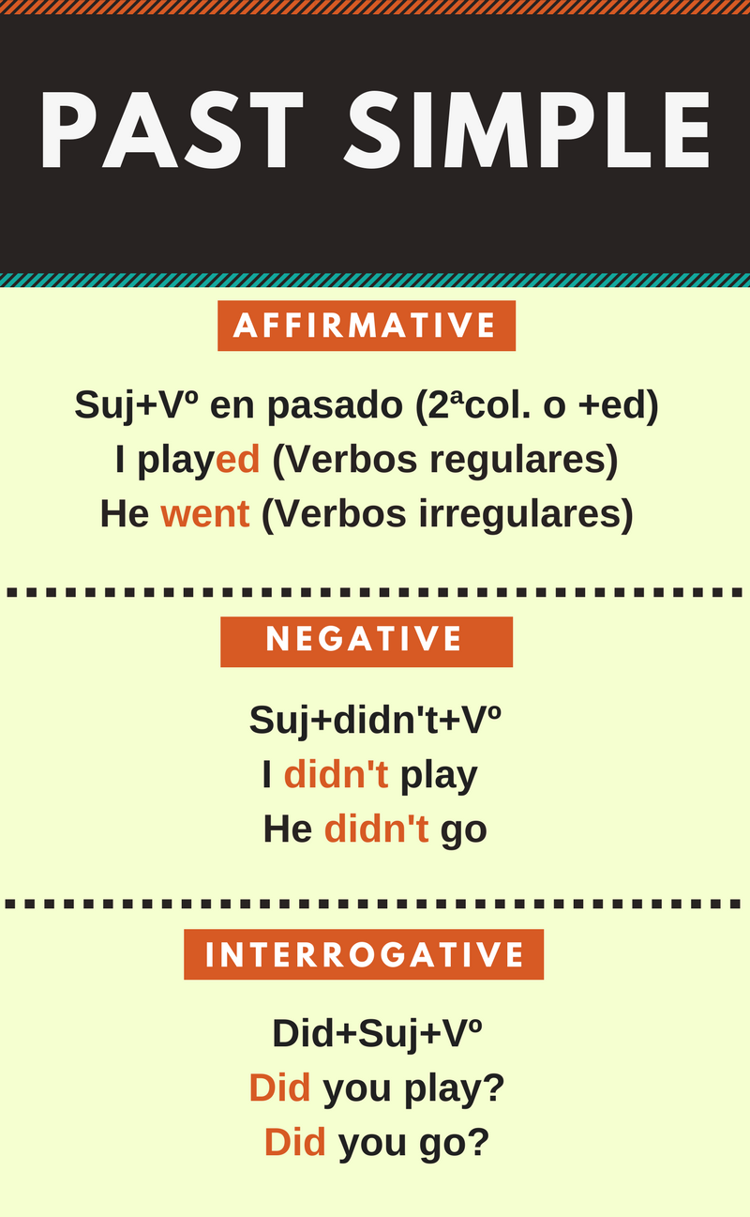

**Past Simple (regular verbs)**

1. Write the Past Simple form of the verbs below in the correct column.

**(Repeat, worry, finish, start, phone, call, miss, enjoy, visit, marry, listen, cry, play, hate, wash, climb, live, arrive, talk, look, stay, ask, clean, travel, open, like, walk, carry, stop, mix, plan, decide, tidy)**

|  |  |  |  |
| --- | --- | --- | --- |
| -ED | - D | CONS + Y | DOUBLE CONS+ - ED |
|  |  |  |  |