Materia: E.D.I (ESPACIO DE DEFINICIÓN INSTITUCIONAL)

Profesor: Roberto Jorge Romero Curso: 6° año

**Trabajo Práctico N° 15**

**Temas**

* Past perfect (affirmative, negative and interrogative)
* Passive voice: present, present continuous, past, past continuous, present perfect and future will / be going to
* Traducciones

1. **Listen and complete the text.**
2. **Reading**
3. **Translate**
4. **Answer the question**

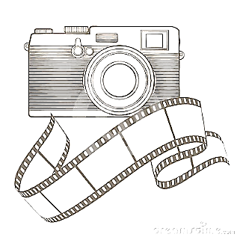PHOTOGRAPHY  
  
Uncle Monty was a **________** relative who had a **________** shop in East London, near Whitechapel station. When I was 15, my dad took me to Uncle Monty’s shop and bought me my **________** camera.  
It was a Zenith-E, **________** in Russia I think, and I’m talking about back in the days when you **________** up the camera and put rolls of 24 or 36 films **________**. You really thought about the photo you were taking before you took it because camera film was **________**.  
I never really took to photography as a hobby. I only took photos of **________**, birthdays, family parties etc. But it was a lot of fun going to the camera shop, or the chemists, to pick up developed photos that had been taken days or weeks **________**.  
When I was 19 I travelled through **________** with a friend and took at least 200 photos of my trip. I made the mistake of sending the rolls of film to the UK by post from Greece and they never **________**. I kind of lost interest in photography after that!  
These days I prefer video and I don’t own a still camera. I only use the one on my **________** phone for the occasional snap.

1. Who was Monty?
2. How old are he when bought his first camera?
3. Where was made his first camera?
4. When did he travel to Europe?
5. Why he lost interest in photography?