Materia: E.D.I (ESPACIO DE DEFINICIÓN INSTITUCIONAL) Curso: 2° año A

Profesora: Ortiz, Irma A.

**Trabajo Práctico N° 8**

Preprositions of place

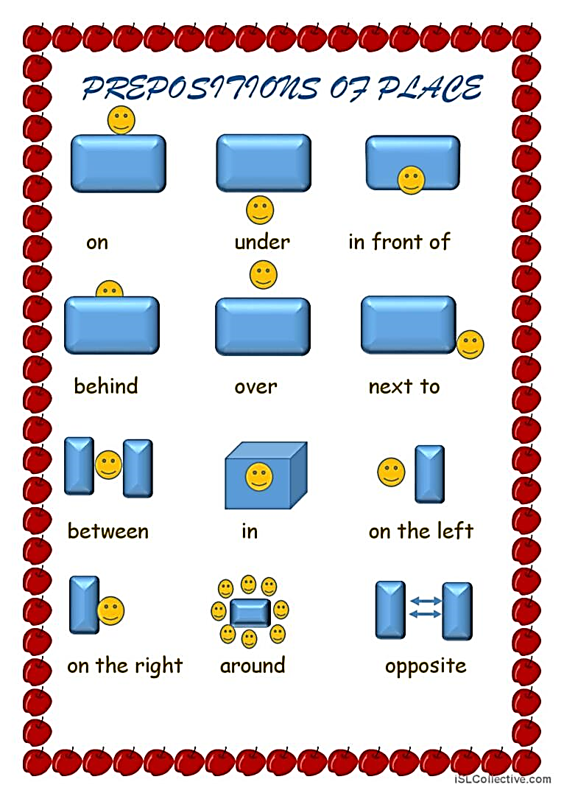

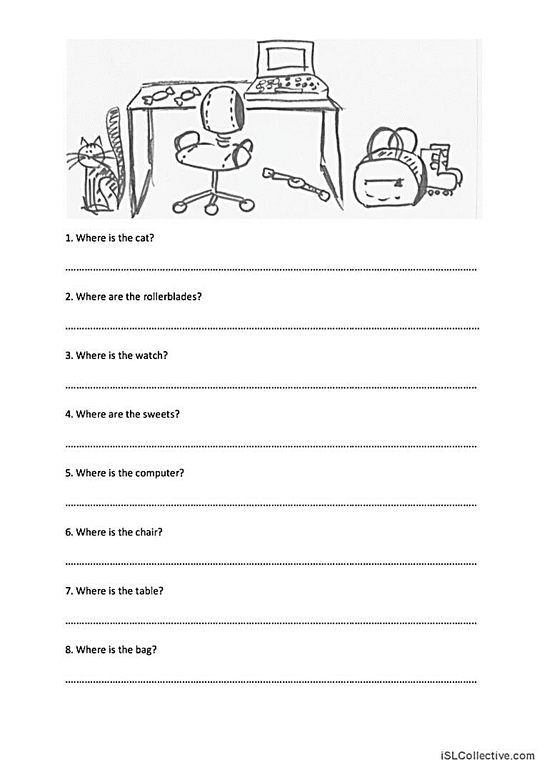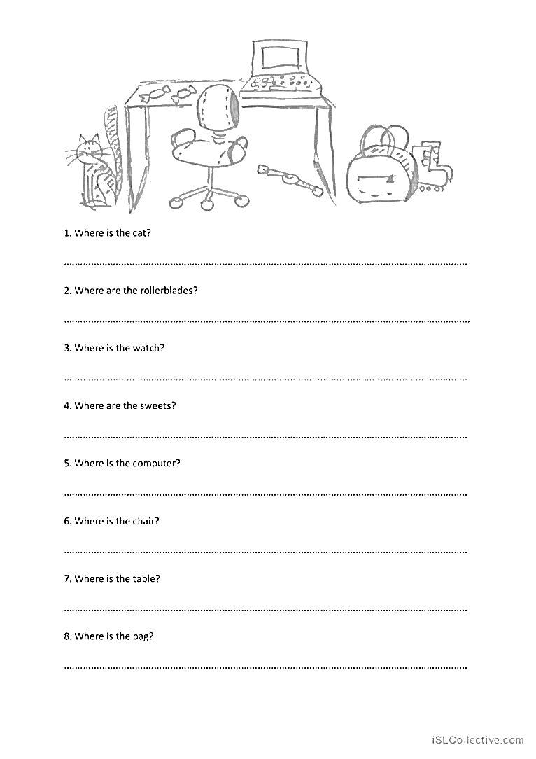

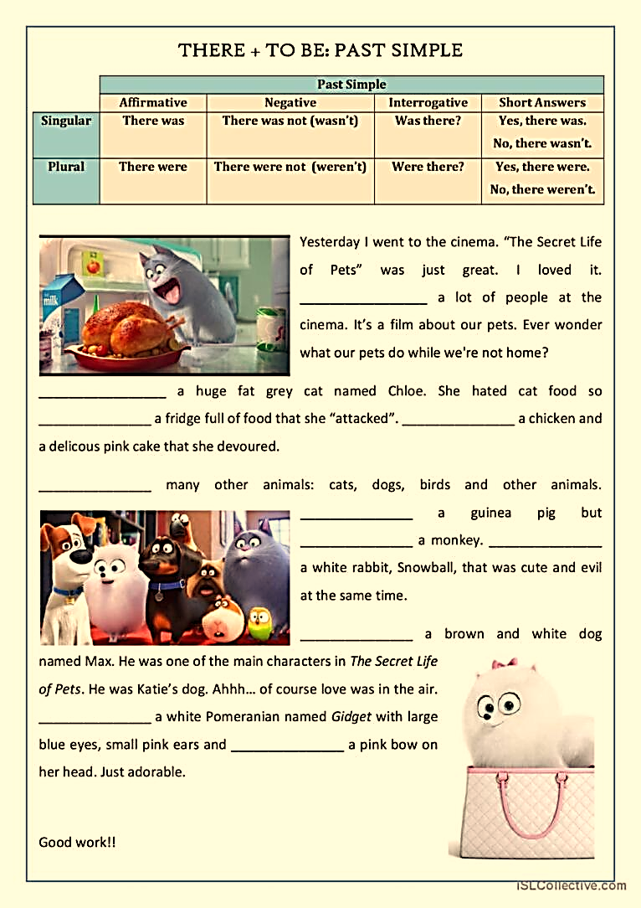

**Complete the sentences using was or were**

1. Last year there __________ a circus in my town
2. There __________ four cinemas in Bahia Blanca in 2004
3. There __________ many fountains in this park 20 years ago
4. There __________ five party at Susan’s yesterday
5. __________ a book on the chair?
6. __________ a tree in the park?
7. __________ any people there (negative)
8. __________ any tables in the kitchen (negative)