Materia: E.D.I (ESPACIO DE DEFINICIÓN INSTITUCIONAL)

Profesora: Ortiz, Irma A.

Curso: 2° año A

**Trabajo Práctico N° 9**

1. **Change the sentences into negative or interrogative forms:**
2. Anne played tennis yesterday (-)

_____________________________________

1. Your friends ate some hamburgers last night (?)

_____________________________________

1. Alex and Chris were in Rio in October (-)

_____________________________________

1. Betina read a whole book yesterday (?)

_____________________________________

1. **Complete with was/were**
2. ______ Mandy at work yesterday?
3. ______ your TV working yesterday?
4. ______ there a Café at your hotel?
5. When ______ you in Canada?
6. **Choose the correct option: there was/there wasn’t/there were/there weren’t**
7. ___________ bows and arrows
8. ___________ fish and meat
9. ___________ any computers
10. ___________ any house
11. **Look at the picture and write T (true) or F (false)**

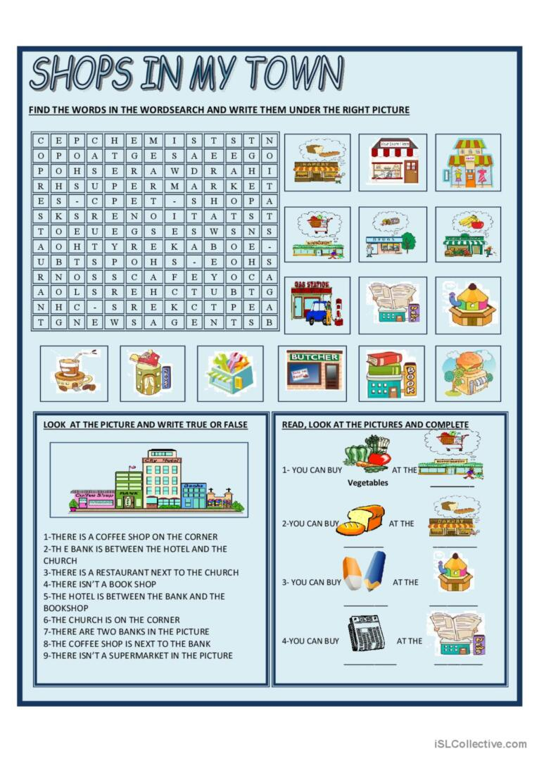

1. The bank is between the hotel and the church
2. There is a restaurant next to the church
3. The coffee shop is next to the bank
4. The hotel is between the bank and the bookshop