Materia: E.D.I (ESPACIO DE DEFINICIÓN INSTITUCIONAL) Curso: 2do año
Profesor: Roberto Jorge Romero
Trabajo Práctico N° 4
a. Choose the correct option
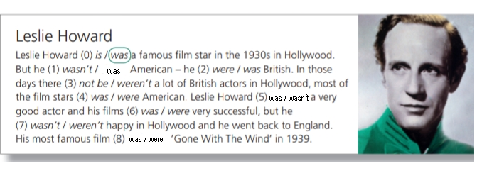
b. Answer
1 was Leslie Howard American?
2 was he a very good actor?
3 was he happy in Hollywood?
4 what was his most famous film?

c. reading in English
D. translate the text

