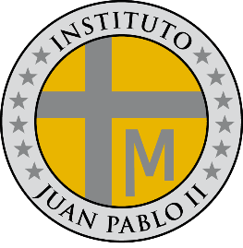**PROGRAMA DE ESTUDIOS**

**LENGUA EXTRANJERA E.D.I**

**INSTITUTO JUAN PABLO II**

Profesor: Roberto Jorge Romero

Nivel: 5º año A

Ciclo lectivo: 2024

**CONTENIDOS CONCEPTUALES**

Unidad Nº 1:

* Future – will and be going to (affirmative, negative and interrogative)
* Verbos pasado and past participle
* First conditional

Unidad Nº 2:

* Second conditional
* Phrasal verbs

Unidad: Nº 3

* Passive voice: present simple by + agent (affirmative, negative and interrogative)
* Passive voice: present continuous by + agent (affirmative, negative and interrogative)
* Passive voice: past simple by + agent (affirmative, negative and interrogative)
* Passive voice: future will by + agent (affirmative, negative and interrogative)