Materia: E.D.I (ESPACIO DE DEFINICIÓN INSTITUCIONAL) Curso: 5to año

Profesor: Roberto Jorge Romero

**1 trimetre**

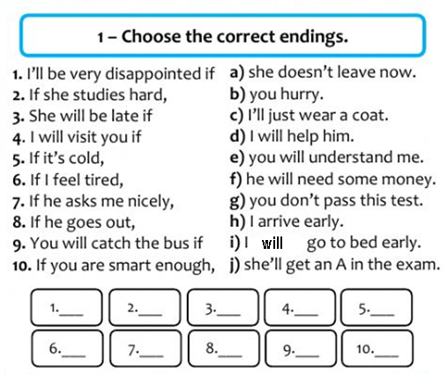

Complete with will or be going to

1. Nobody in Jane's team can play basketball. They ________(lose) the match.
2. Why are you putting on your coat? I _________(go) out.
3. Look! That car has had an accident. Oh, no. I _________ (call) an ambulance!
4. In the future, people _________ (live) in ecological homes.
5. He's driving too fast. He __________ (have) an accident.

**2 trimestre**

1. Complete the following sentences using the correct form of the verbs. 2 conditional

1. It’s Monday today, but if it _____________ (be) Saturday, I _____________ (go) to the beach.

2. I don’t have any money now, but if I ______________ (have) some, I ____________ (lend) it to you.

3. I have to work tomorrow, but if I _______________ (be) free, I _____________ (go) shopping with you.

4. Amy can only speak one language, but if she ________________ (can) speak two languages, she___________________ (apply) for a job at the Multicultural Center.

5. Sue doesn’t know how to knit. If she ___________________ (know) how to knit, she ____________________ (make) a sweater for you for your birthday.

6. I don’t own a pair of skis. If I _____________ (have) skis, I _______________ (go) skiing with you tomorrow.

**3 trimestre**

1. Rewrite these sentences in the passive voice.

a. Someone built this house 200 years ago.___________________________________

b. A thief stole my purse._____________________________________________

c. The police will arrest the robbers.___________________________________

d. They produce cars in this factory._________________________________________

e. They serve breakfast at eight o’clock every day._____________________________

f. People throw away tones of rubbish every day._______________________________

g. They make coffee in Brazil.____________________________________

h. Someone stole Jim’s bike last night._______________________________________

2. Rewrite these sentences in the passive voice.

a. They will build a new bridge next year._____________________________________

b. Brian Brody directed The Ultimate Space Adventure.________________________

c. Pierre Matie will design her costume.____________________________

d. Someone found my wallet._______________________________

e. One of the students broke the window._____________________________________

f. They will deliver my computer on Monday._________________________________