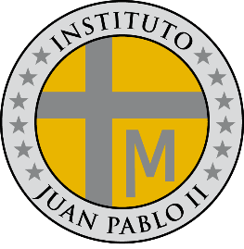**PROGRAMA DE ESTUDIOS**

**LENGUA EXTRANJERA E.D.I**

**INSTITUTO JUAN PABLO II**

Profesor: Roberto Jorge Romero

Nivel: 4º año B

Ciclo lectivo: 2024

**CONTENIDOS CONCEPTUALES**

Unidad Nº 1:

* Compounds some / any / no / every
* Have to – don´t have to
* Had to – didn´t have to

Unidad Nº 2:

* Future – be going to (affirmative, negative and interrogative)
* Will (affirmative, negative and interrogative)
* Will and be going to

Unidad: Nº 3

* Preset perfect (affirmative, negative and interrogative)
* Just, already, yet
* Past participle
* Ever and never
* Since, for