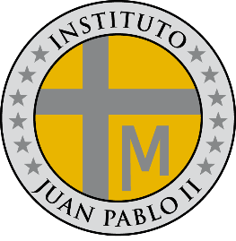**PROGRAMA DE ESTUDIOS**

**LENGUA EXTRANJERA E.D.I**

**INSTITUTO JUAN PABLO II**

Profesor: Roberto Jorge Romero

Nivel: 3º año B

Ciclo lectivo: 2024

**CONTENIDOS CONCEPTUALES**

Unidad Nº 1:

* Present simple and present continuous
* There was – there were (affirmative, negative and interrogative)
* Verb to be past simple

Unidad Nº 2:

* Past simple regular, irregular form(affirmative, negative and interrogative)
* Past continuous (affirmative, negative and interrogative)
* Past simple and past continuous (affirmative, negative and interrogative)

Unidad: Nº 3

* Countable and uncountable nous
* A lot of, much, many
* How much, how many