Materia: E.D.I (ESPACIO DE DEFINICIÓN INSTITUCIONAL) Curso: 3er año

Profesor: Roberto Jorge Romero

**1 trimestre**

a. Ejercicio 2 Haz preguntas para las siguientes respuestas.

1. **Do you live in Malaga**_______? Yes, I live in Malaga.

2. __________________________? No, I don’t play the guitar.

3. __________________________? Yes, he gets up at 7.

4. __________________________? Yes, he likes science-fiction.

5. __________________________? No, we don’t drink alcohol.

6. __________________________? No, they don’t go to the park.

7. __________________________? Yes, she wears an uniform.

8. __________________________? No, Ethan doesn’t study a lot.

9. __________________________? Yes, Mia plays basketball.

10. __________________________? No, I don’t walk to school.

b. Complete the sentences in present continuous with the verbs given.

1. The birds ............... (sing).

2. My sister ............... (not/watch) TV and I ............... (read) a great novel.

3. We ............... (have) a very good time on holidays.

4. She ............... (work) at the moment but she finishes at 6.

5. ...... it ...... (rain) now? Yes, it is.

6. James ............... (play) football in the park now.

7. Harry and Anne ............... (not/go) to the cinema.

8. They ............... (clean) the whole house.

**2 trimestre**

Order and answer them

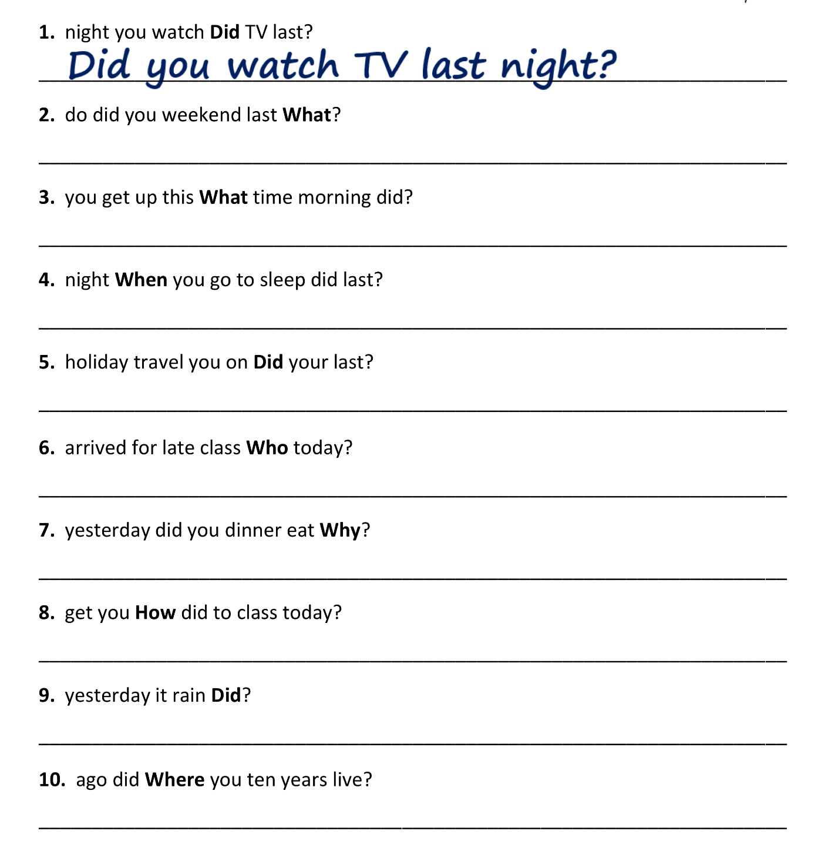

**3 trimestre**

Put in the correct indefinite pronoun

**(SOMEBODY / SOMETHING / SOMEWHERE / ANYBODY / ANYTHING /**

**ANYWHERE / NOBODY / NOTHING / NOWHERE / EVERYBODY / EVERYTHING / EVERYWHERE).**

1. She wants to live ________________ by the sea.

2. She put ________________ in the box, all the things that she had.

3. Does ________________ have a phone charger?

4. We went ________________ this weekend. We stayed at home.

5. She didn’t bring ________________ to the party.

6. Is there ________________ in the room?

7. A: What’s wrong? B: ________________, I’m fine.

8. ________________ lives in that house. It’s empty.

9. Would you like to go ________________ this weekend?

10. ________________ was really friendly, all the managers and even the CEO.

11. ________________ is going really well and so I’m really happy.

12. I know ________________ in this company. It’s my first day.

Are these nouns countable or uncountable?

1. water ____________

2. fruit ____________

3. coconut ____________

4. bread ____________

5. DVD ____________

6. meat ____________

7. ball ____________

8. snack ____________

9. glasses ____________

10. pen ____________

Complete with MUCH, MANY or A LOT OF

1. We have __________ oranges.
2. We don't have __________ bananas, and we don't have __________ fruit juice.
3. Do you have any cereal? Sure, there's __________ in the kitchen.
4. How ___________ is this? It's ten dollars.
5. How ___________ do you want? Six, please.
6. He's very busy; he has __________ work to do.
7. David has ___________ rice, but Tyler doesn't have ___________.
8. London has ____________ beautiful buildings.
9. They eat ___________ apples.