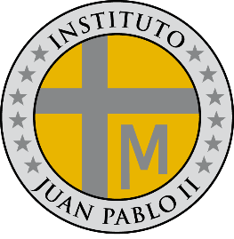**PROGRAMA DE ESTUDIOS**

**LENGUA EXTRANJERA E.D.I**

**INSTITUTO JUAN PABLO II**

Profesor: Roberto Jorge Romero

Nivel: 2º año B

Ciclo lectivo: 2024

**CONTENIDOS CONCEPTUALES**

Unidad Nº 1:

* Be past simple (affirmative, negative and interrogative and short answer)
* Information question with was and were
* Prepositionof place
* There was and there were

Unidad Nº 2:

* Past simple regular verbs (affirmative)
* Past simple irregular verbs (affirmative)
* Past simple (affirmative, negative and interrogative)
* Question words past simple

Unidad: Nº 3

* Comparative adjectives (short, long, irregular)
* Superlative adjectives
* As – as