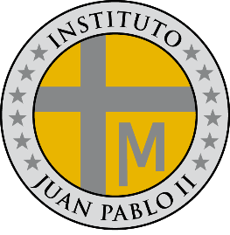**PROGRAMA DE ESTUDIOS**

**LENGUA EXTRANJERA E.D.I**

**INSTITUTO JUAN PABLO II**

Profesor: Roberto Jorge Romero

Nivel: 1º año B

Ciclo lectivo: 2024

**CONTENIDOS CONCEPTUALES**

Unidad Nº 1:

* Greetings / saludos
* Personal pronouns: I, you, he, she, it....etc. / pronombres personales
* Question words
* Verb to be (affirmative, negative and interrogative)
* Have got (affirmative, negative and interrogative)

Unidad Nº 2:

* Present simple 3 person (affirmative)
* Present simple (negative, interrogative and short answer)
* Question words

Unidad: Nº 3

* Can ability (affirmative, negative and interrogative)
* Present continuous (affirmative, negative and interrogative)