Materia: E.D.I (ESPACIO DE DEFINICIÓN INSTITUCIONAL) Curso: 4do año

Profesor: Roberto Jorge Romero

**Trabajo Práctico N° 61**

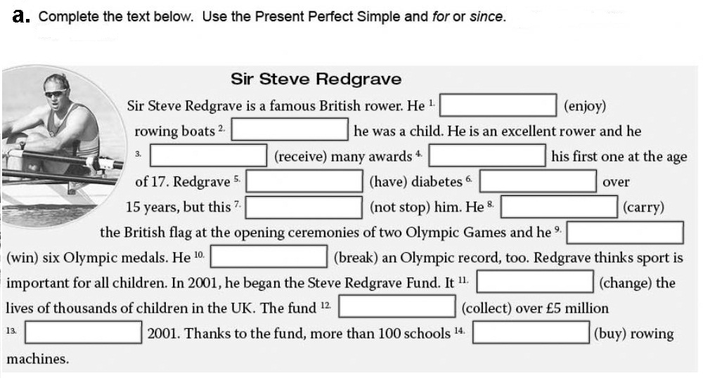

**b.** Answer

1. Has Steve Redgrave received many awards?
2. Has he had diabetes?
3. What has he carried in the Olympic Games?
4. How many medals has he won?