Materia: E.D.I (ESPACIO DE DEFINICIÓN INSTITUCIONAL) Curso: 4do año

Profesor: Roberto Jorge Romero

**Trabajo Práctico N° 55**

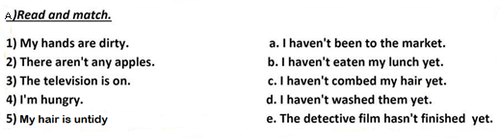

b. Write the participle form of the following verbs.

1. go →
2. sing →
3. be →
4. buy →
5. do →
6. break→
7. choose→
8. forget→
9. dream→
10. understand→

c. Complete the table in present perfect simple.

|  |  |  |
| --- | --- | --- |
| **positive** | **negative** | **question** |
| 1 He has written a letter. |  |  |
|  | 2 They have not stopped |  |
|  |  | 3 Have we danced? |
| 4 She has worked. |  |  |
|  | 5 Andy has not slept |  |

1. Write sentences in present perfect simple.
2. they / ask / a question -
3. he / speak / English -
4. I / be / in my room -
5. we / not / wash / the car -
6. Annie / not / forget / her homework –

d. Write questions in present perfect simple.

1. they / finish / their homework -
2. Sue / kiss / Ben -
3. the waiter / bring / the tea -
4. Marilyn / pay / the bill -
5. you / ever / write / a poem -