|  |  |
| --- | --- |
| **INSTITUTO JUAN PABLO II** | **LENGUA EXTRANJERA “INGLÉS”** |
| * **CURSO:** 5 A * **LIBRO:** Metro 3 (Oxford) | **TRABAJO PRÁCTICO**  ***N° 50*** |
| * **DOCENTE:** NAHIR RODRIGUEZ BREA |
| * **CICLO LECTIVO:** 2024 |

**UNIT N°3:**

**MAN-MADE AND NATURAL PROBLEMS**

**Evaluative tp**

1. **In groups no more than 4 members describe and compare the following pictures, use the following words to help you**

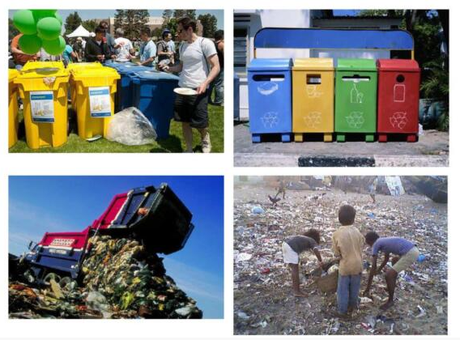

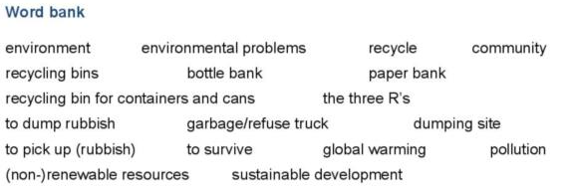

Answer the following questions in a sheet of paper

