Materia: E.D.I (ESPACIO DE DEFINICIÓN INSTITUCIONAL) Curso: 3er año

Profesor: Roberto Jorge Romero

**Trabajo Práctico N° 49**

**Pronombres indefinidos**

Los pronombres indefinidos no se refieren a una persona, lugar o cosa específicos. En inglés, existe un grupo particular de pronombres indefinidos formados por un cuantificador o distributivo precedido por *any, some, every*y *no*.

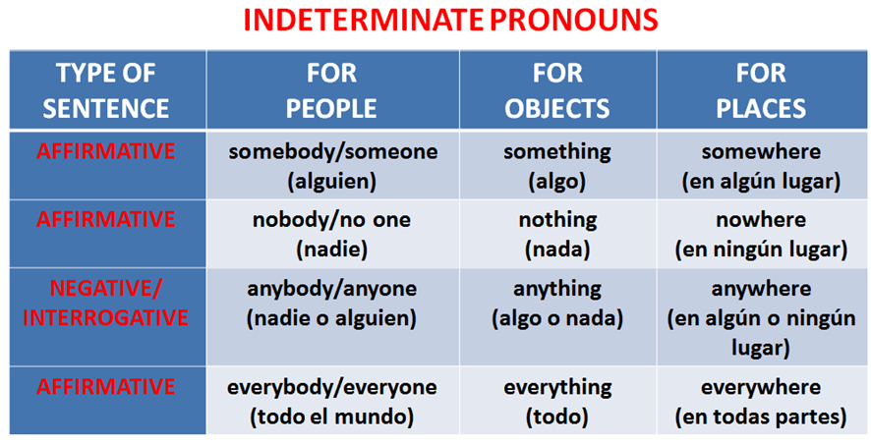

1. Choose the correct answer.

Would you like **something/everybody** to eat?

It was really dark and I couldn't see **anything/something.**

Does **anybody/nobody** live in that house?score

It doesn't matter where we go, We can go **anywhere/anything** we want to.

This is boring. There's **nothing/everything** to do.

The shop is closed. **Everybody/something** has gone home.

The guidebook says there's a good hotel **somewhere/anywhere** near here.

1. Complete the sentences using the words from the box.

**ANYONE - ANYTHING – ANYWHERE – EVERYBODY –**

**NOBODY - SOMEONE**

1. Do you have ________________ in your coat pocket? – Let's see.

2. Jonathon is speaking to ________________ on the phone.

3. Aimee didn't tell her secret to ________________.

4. The headmaster is very popular at school. ________________ likes him.

5. My boyfriend likes to be at home. He doesn't want to go _____________ after dark.

6. The room was empty. There was ________________ to talk to.