Materia: E.D.I (ESPACIO DE DEFINICIÓN INSTITUCIONAL) Curso: 5to año

Profesor: Roberto Jorge Romero

**Trabajo Práctico N° 43**

**Passive voice**

**Past simple**

* Hasta ahora hemos hablado de la voz activa donde enfocamos la acción del verbo en el sujeto. Pero cuando queremos dar más importancia a la acción y no a quien la ha realizado, utilizamos la voz pasiva.

Ejemplos:

**La voz activa**

He ate all of the cookies.(Comió todas las galletas.)

**La voz pasiva**

All of the cookies were eaten.(Todas las galletas fueron comidas.)

* Se forma la voz pasiva con el verbo auxiliar “to be” y el participio pasado del verbo.

**Sujeto + verbo auxiliar (to be) + participio pasado…**

Ejemplos:

The speech is written for the president.(El discurso está escrito para el presidente.) The house was built in 1975.(La casa fue construida en 1975.)

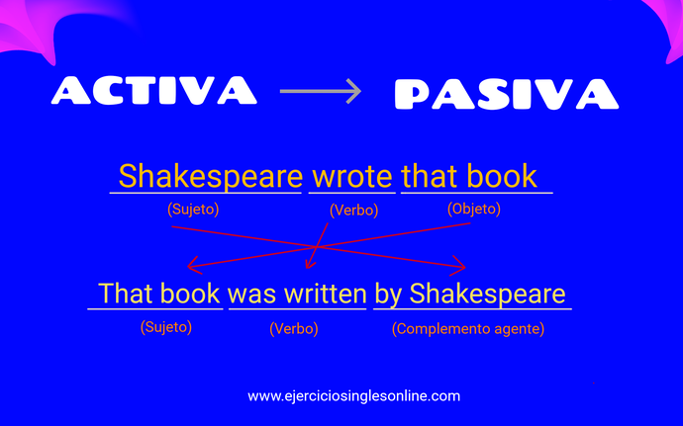

***Rewrite the sentence in the passive voice:***

1. Mark Twain wrote "The Adventures of Tom Sawyer" in 1876.
2. Tom and David make many movies in Hollywood.
3. Does my family receive the newspaper every day.
4. Did John deliver your new sofa?
5. I put the glasses on the table yesterday.
6. Jason didn´t feed the animals yesterday at 10 o'clock.
7. My family listened to a strong noise coming from the street.
8. Mary studies English every day.
9. Emily drank two pints at Paul's house.
10. Paleontologist found two fossils of mammoth.
11. The English archaeologist Howard Carter discovered the tomb of Tutankhamen in 1923.
12. My mother didn't recognize Mary at first sight.
13. Kevin doesn't know her.
14. The nurse examined the patient.
15. Did my son clean the windows?
16. The fire destroyed the building.
17. That dog bit the boy in my uncle´s house yesterday.