Materia: E.D.I (ESPACIO DE DEFINICIÓN INSTITUCIONAL) Curso: 1er año

Profesor: Roberto Jorge Romero

**Trabajo Práctico N° 23**

**Reglas ING**

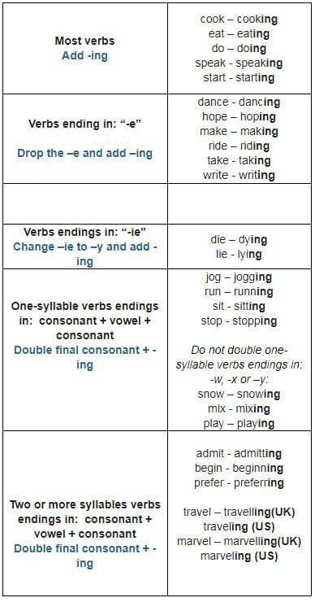

1. Coloca correctamente la ING a los siguientes verbos
2. Use: ____US**ING**____
3. Wash: ___________
4. Rain: ____________
5. Chat: ____________
6. Do: _____________
7. Sit: ____________
8. Have: _____________
9. Lie: ____________
10. Watch: ___________
11. Play: ____________
12. Escribe las palabras en el orden correcto.

Q1 football / not / playing / now / they / are

Q2 the / ? / game / going / you / are / to

Q3 moment / the / doing / I / homework / my / at / am

Q4 playing / is / guitar / he / ? / the / now

Q5 watching / raining / they / is / television / are / it / so